Contents

Anti-Aliasing/Reconstruction Filters Simulations 4

Nth Order Butterworth filters Method 5

Nth Order Capacitor Method 1 6

Nth Order Capacitor and Resistors Method 2 8

Nth Order Resistor Method for Switched-Capacitor Filter 9

Simulating Frequency Response 10

MATLAB and Simulink Simulations 10

Second Order Butterworth Filter 12

Fourth Order Butterworth Filter 14

Fifth Order Butterworth Filter 16

Eighth and Sixteenth Order Butterworth Filter 18

Simulink Summary 21

LT Spice Simulations 21

Second Order Butterworth Filter 21

Fourth Order Butterworth Filter 22

Fifth Order Butterworth Filter 22

Eighth Order Butterworth Filter 23

Sixteenth Order Butterworth Filter 24

LT Spice Simulation Summary 24

References 25

Appendices 25

Butterworth Filter MATLAB Scripts 25

Filter Poles.m 25

Cal_tf.m 26

Cal_components.m 27

FreqResp.m 28

simulating_tf.m 29

sim_tf.slx 30

MATLAB Results 30

Component Values (Method 1 and 2) 30

Switched Capacitor Values 31

Transfer Function Coefficients 32

LT Spice Circuits 33

Nth order 33

Second Order Butterworth Filter 34

Fourth Order Butterworth Filter 35

Fifth Order Butterworth Filter 35

Eighth Order Butterworth Filter 36

Sixteenth Order Butterworth Filter 37

Standard Capacitor and Resistor values (McClure, n.d.) 38

Equation 1 6

Equation 2 6

Equation 3 6

Equation 4 6

Equation 5 6

Equation 6 6

Equation 7 7

Equation 8 7

Equation 9 7

Equation 10 7

Equation 11 9

Table 1 - Shows the Q Factor, R2, R3 and C2, C4 values for the 6th order filter 8

Table 2 - Shows the standard capacitor values used for the 6th order Butterworth filter 8

Table 3 - Shows the components calculated for a 6th order Butterworth Filter 9

Table 4 - Table comparing resistors and capacitors calculated from method 1 and 2 9

Table 5 - Shows the tabulated results of the Q factor, R2 and R3 for a 6th Order Butterworth filter 10

Table 6 - Shows the System Transfer Functions for each order 11

Figure 1 - Shows one stage of the Butterworth filter 5

Figure 2 - Shows the use of the buttap function, here, n = 6 6

Figure 3 - Shows the polynomials for each section when n = 6 6

Figure 4 - Shows a 6th order Butterworth Filter 8

Figure 5 - The frequency response from an ideal low pass filter 12

Figure 6 - Shows the frequency response of a 2nd order Butterworth filter at four different frequencies, 200Hz (Top Left), 500Hz (Top Right), 800Hz (Bottom Left), and 5000Hz (Bottom right) 13

Figure 7 - Shows the Frequency response of the 2nd Order Butterworth filter 14

Figure 8 - Shows the group delay for the second order Butterworth filter 14

Figure 9 - Shows the frequency response of a 4th order Butterworth filter at four different frequencies, 200Hz (Top Left), 500Hz (Top Right), 800Hz (Bottom Left), and 5000Hz (Bottom right) 15

Figure 10 - Shows the Frequency response of the 4th Order Butterworth filter 16

Figure 11 - Shows the group delay for the fourth order Butterworth filter 16

Figure 12 - Shows the frequency response of a 5th order Butterworth filter at four different frequencies, 200Hz (Top Left), 500Hz (Top Right), 800Hz (Bottom Left), and 5000Hz (Bottom right) 17

Figure 13 - Shows the Frequency response of the 5th Order Butterworth filter 18

Figure 14 - Shows the group delay for the fifth order Butterworth filter 18

Figure 15 - Shows the frequency response of an 8th order Butterworth filter at four different frequencies, 200Hz (Top Left), 500Hz (Top Right), 800Hz (Bottom Left), and 5000Hz (Bottom right) 19

Figure 16 - Shows the frequency response of a 16th order Butterworth filter at four different frequencies, 200Hz (Top Left), 500Hz (Top Right), 800Hz (Bottom Left), and 5000Hz (Bottom right) 20

Figure 17 - Shows the Frequency response of the 8th Order Butterworth filter 21

Figure 18 - Shows the Frequency response of the 16th order Butterworth filter 21

Figure 19 - Shows the Group Delay of the 8th order filter (Left) and the 16th order filter (Right) 21

Figure 20 - Shows the frequency response of the 2nd order Butterworth filter using both method 1 (Blue) and method 2 (Green) 22

Figure 21 - Shows the frequency response of the 4th order Butterworth filter using both method 1 (Green) and method 2 (Blue) 23

Figure 22 - Shows the frequency response of the 5th order Butterworth filter using both method 1 (Green) and method 2 (Blue) 23

Figure 23 - Shows the frequency response of the 8th order Butterworth filter using both method 1 (Green) and method 2 (Blue) 24

Figure 24 - Shows the frequency response of the 16th order Butterworth filter using both method 1 (Green) and method 2 (Blue) 25

# Anti-Aliasing/Reconstruction Filters Simulations

This section consists of introducing the method for calculating the polynomials for the Butterworth filters, and then using these polynomials to calculate the required components using method 1 and method 2, and finally to calculate the resistor values for the switched-capacitor style filter.

In the project, a fourth order Butterworth filter is used for both the anti-aliasing and reconstruction filters, in (Ete, 2016) it is recommended to use a 16th order Butterworth filter for these filters. In (Dennis, 2020) 5th order Butterworth filter is used in the ANC system. And finally in (Pang, 2019) the 4th order developed by Ete in their project is used.

Using MATLAB, Simulink, and LT Spice, it is possible to calculate the required coefficients for each order and the electrical components to build the circuit. Then simulate these calculated transfer function and also simulate these calculated components to understand the frequency response.

The Butterworth filter designs are each cascaded to create a higher order of low pass filters; therefore a standard stage can be created to help with designing of the Nth order filter as seen in Figure 1. For instance, Figure 1 shows a second order Butterworth filter and two of these can be connected together to create a fourth order Butterworth filter. For odd number filters, a first order filter is used, where C2_a and R3_a from Figure 1 are equal to zero.

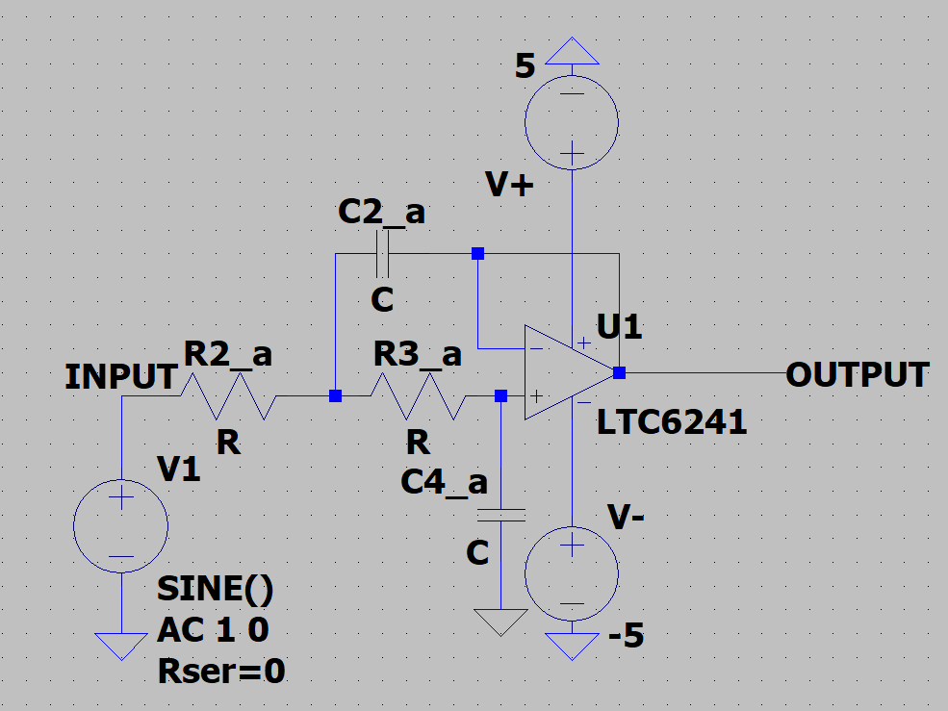

Figure - Shows one stage of the Butterworth filter

## Nth Order Butterworth filters Method

Using MATLAB it is possible to calculate the zeros, poles and gain for an nth order filter using [z,p,k]=buttap(n) function, where z is the zeros, p is the poles, k is the gain, and n is the desired order. An example is shown in Figure 2.

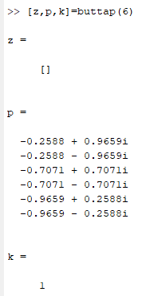

Figure - Shows the use of the buttap function, here, n = 6

The poles given are what are required to calculate the denominator of the transfer function of the system. The poles are split into pole pairs and used to calculate the polynomial for each section of the filter, which are used later to determine the components, the polynomials are seen in Figure 3.

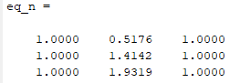

Figure - Shows the polynomials for each section when n = 6

As seen from Figure 3, the polynomials are as follows:

Equation

Equation

Equation

With all polynomials found, these are then multiplied to gain the denominator which is shown in Equation 4.

Equation

The desired cut-off frequency, $f_{c}$, is 500Hz for this project, therefore s is replaced by $\frac{s}{w_{c}}$, where $w_{c}=2πf_{c}=2000π$. Therefore the denominator is now:

Equation

Equation 5 shows the denominator for a 6th order Butterworth filter, which can now be simulated in Simulink and therefore the frequency response and group delay can be analysed.

## Nth Order Capacitor Method 1

Method from (Ete, 2016).

The polynomials found from each pole pair are in the form of Equation 6.

Equation

The Q factor is required to configure the stages in the correct order, the stages must be placed by increasing Q factor to limit any saturation in each stage (Mancini, 2003). Equation 7 shows how to calculate the Q factor and how this value relates to the components.

Equation

The coefficient, $a_{i}$, is equal to ${2C}_{4}$ and $C_{2}C_{4}=1$, therefore from these equations the capacitance values can be found.

Equation

The actual capacitance values are then found by using the FSF and scaling factor, where FSF = $w_{c}$ and the scaling factor is chosen as 10,000. The new values are then found using Equation 9.

Equation

Therefore giving Equation 10:

Equation

The resistors are found by multiplying 1Ω by the scaling factor. Therefore for a 6th order Butterworth filter the resistors R2 and R3 are 100kΩ and so the schematic would be as follows:

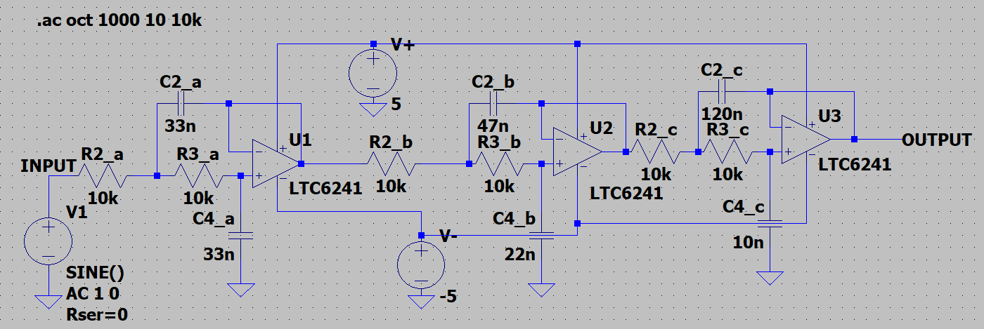

Figure - Shows a 6th order Butterworth Filter

As seen from Figure 4, the base stage is cascaded with 2 others in order of Q, each with different capacitor values, these are shown in Table 1.

Table - Shows the Q Factor, R2, R3 and C2, C4 values for the 6th order filter

|  |  |  |  |  |
| --- | --- | --- | --- | --- |
| Q Factor | R2(kOhm) | R3(kOhm) | C2 Values (nF) | C4 Values (nF) |
| 1.931851653 | 10 | 10 | 122.9854959 | 8.238466079 |
| 0.707106781 | 10 | 10 | 45.01581581 | 22.5079079 |
| 0.51763809 | 10 | 10 | 32.95386432 | 30.74637398 |

Table 2 shows the actual values for the capacitors, C2 and C4, as the calculated values need to be converted to standard capacitor values. This is done using (McClure, n.d.) capacitor and resistor standard values, also shown in the appendix.

Table - Shows the standard capacitor values used for the 6th order Butterworth filter

|  |  |
| --- | --- |
| $$C_{2, new}$$ | $$C_{4,new}$$ |
| 100nF | 10nF |
| 47nF | 22nF |
| 33nF | 33nF |

## Nth Order Capacitor and Resistors Method 2

A second method for determining the capacitors and resistors is found from (Mancini, 2003).

Where

$$C_{2,i}\underline{>} C_{4,i}*\left(\frac{{4b}_{i}}{a_{i}^{2}}\right)$$

$$R_{2,i}= \frac{a_{i}C_{2,i}- \sqrt{a_{i}^{2}C_{2,i}^{2}-4b_{i}C_{2,i}C_{4,i}}}{4πf_{c}C_{2,i}C_{4,i}}$$

$$R_{3,i}= \frac{a_{i}C_{2,i}+ \sqrt{a_{i}^{2}C_{2,i}^{2}-4b_{i}C_{2,i}C_{4,i}}}{4πf_{c}C_{2,i}C_{4,i}}$$

C4 is set to 10nF and therefore C2, R2 and R3 can be calculated. For 6th order, the components are calculated below. These were converted from calculated values to standard values using (McClure, n.d.).

Table - Shows the components calculated for a 6th order Butterworth Filter

|  |  |  |  |
| --- | --- | --- | --- |
| C4 (nF) | C2 (nF) | R2 (kΩ) | R3 (kΩ) |
| 10 | 150 | 10 | 10 |
| 10 | 20 | 22 | 22 |
| 10 | 10 | 31 | 31 |

Comparing the components calculated using these two methods in the table below:

Table - Table comparing resistors and capacitors calculated from method 1 and 2

|  |  |  |  |  |  |  |  |
| --- | --- | --- | --- | --- | --- | --- | --- |
| **Method 1 $C_{2, new}$** (nF) | **Method 1 $C_{4,new}$** (nF) | **Method 2** C2 (nF) | **Method 2** C4 (nF) | **Method 1** R2 (kΩ) | **Method 1** R3 (kΩ) | **Method 2** R2 (kΩ) | **Method 2** R3 (kΩ) |
| 100 | 10 | 150 | 10 | 10 | 10 | 10 | 10 |
| 47 | 22 | 20 | 10 | 10 | 10 | 22 | 22 |
| 33 | 33 | 10 | 10 | 10 | 10 | 31 | 31 |

From Table 4 it can be seen that the values found from the two methods are relatively similar in comparison. Both of these methods were implemented into LT Spice and simulated to compare their frequency responses.

## Nth Order Resistor Method for Switched-Capacitor Filter

Previously, the resistors are set at 10kΩ in method 1 or calculated in method 2 and this works for the simulations, however, when implementing the switched-capacitor filter, the resistors are calculated using the Q factor, or Quality Factor. The switched-capacitor filters are clock tuneable which allows the ability to change the cut off frequency. This type also doesn’t require external capacitors, only resistors.

Equation 7 shows how to calculate the Q factor, using the coefficients of each stage polynomial, therefore each stage has its own Q factor. This Q factor can then be used to calculate the required resistors. The resistor R2, is set to 100kΩ, and then R3 can be calculated using Equation 11.

Equation

For the 6th Order example, the Q factors and resistors are tabulated below.

Table - Shows the tabulated results of the Q factor, R2 and R3 for a 6th Order Butterworth filter

|  |  |  |  |
| --- | --- | --- | --- |
| Stage | Q Factor | $$R_{2}$$ | $$R_{3}$$ |
| 3 | 1.932 | 100kΩ | 180kΩ |
| 2 | 0.707 | 100kΩ | 68kΩ |
| 1 | 0.518 | 100kΩ | 51kΩ |

R2 is chosen as 100kΩ, and R3 is calculated and then rounded to the closest standard value resistor.

Having calculated the value of Q, it is advisable to cascade them in order of the quality factor, therefore in Table 5, the stages are numbered to indicate which stage comes first.

# Simulating Frequency Response

This section consists of analysing the results gained from simulating the Nth order Butterworth filters created in the previous section. First is the MATLAB and Simulink simulations which test the frequency response and group delay of each order using the generated transfer function for each model. Second is the simulations of the filters using real components in LT Spice and evaluating the given frequency response of using method 1 and method 2 to calculate the required components.

Once the Nth order transfer function and components have been calculated, the frequency response can be found for each system. First, testing the response at different frequencies of interest, such as the cut off frequency, a frequency less than the cut off frequency, a frequency above the cut off frequency and finally a frequency ten times the cut frequency. Using these the steepness of the roll off can be observed and evaluated for each order along with other items of interest from the graphs.

For the simulations, several order Butterworth filters are considered: 2nd order, 4th order, 5th order, 8th order and 16th order. This will give a large data set to compare and evaluate the Butterworth filters and determine if the 16th order would be best as recommended in (Ete, 2016).

## MATLAB and Simulink Simulations

The Simulink simulations use the transfer function of the nth order system to gain the frequency response. Very simply the signal is observed before and after the transfer function at different frequencies and depending on the frequency the signal amplitude is reduced or not.

First the full transfer functions for each order can be seen in Table 6.

Table - Shows the System Transfer Functions for each order

|  |  |
| --- | --- |
| Order | Transfer Function |
| 2nd | $$\frac{1}{{1.013*10}^{-7}s^{2}+{4.502*10}^{-4}s+1}$$ |
| 4th | $$\frac{1}{{1.027*10}^{-14}s^{4}+{8.428*10}^{-11}s^{3}+{3.459*10}^{-7}s^{2}+{8.318*10}^{-4}s+1}$$ |
| 5th | $$\frac{1}{{3.268*10}^{-18}s^{5}+{3.322*10}^{-14}s^{4}+{1.689*10}^{-10}s^{3}+{5.305*10}^{-7}s^{2}+{1.03*10}^{-3}s+1}$$ |
| 8th | $$\frac{1}{\begin{aligned}{1.054*10}^{-28}s^{8}+{1.697*10}^{-24}s^{7}+{1.366*10}^{-20}s^{6}+{7.139*10}^{-17}s^{5}+{2.637*10}^{-13}s^{4}+ \\ {7.046*10}^{-10}s^{3}+{1.331*10}^{-6}s^{2}+{1.632*10}^{-3}s+1\end{aligned}}$$ |
| 16th | $$\frac{1}{\begin{matrix}{(1.111*10}^{-56}s^{16}+{3.56*10}^{-52}s^{15}+{5.705*10}^{-48}s^{14}+{6.056*10}^{-44}s^{13}+{4.757*10}^{-40}s^{12} \\ {+{2.929*10}^{-36}s^{11}+{1.416*10}^{-32}s^{10}+{6.015*10}^{-29}s^{9}+2.066*10}^{-25}s^{8}+{5.936*10}^{-22}s^{7} \\ +{1.423*10}^{-18}s^{6}+{2.816*10}^{-15}s^{5}+{4.514*10}^{-12}s^{4}+{5.671*10}^{-9}s^{3}+{5.273*10}^{-6}s^{2}+{3.247*10}^{-3}s+1)\end{matrix}}$$ |

From the table it can be seen that each transfer function highest denominator power is equal to the order of the system.

The ideal filter will be a right angle at the cut off frequency as seen in Figure 5. However this is not attainable and there is a trade-off between better frequency response and group delay.

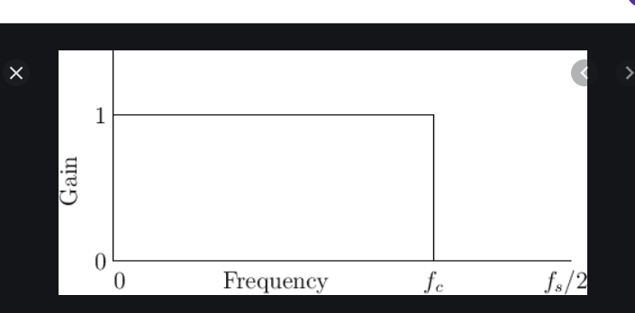

Figure - The frequency response from an ideal low pass filter

### Second Order Butterworth Filter

Using the transfer function from Table 6, the frequency response of four frequencies are found, 200Hz, 500Hz, 800Hz and 5000Hz, along with the group delay.

Figure - Shows the frequency response of a 2nd order Butterworth filter at four different frequencies, 200Hz (Top Left), 500Hz (Top Right), 800Hz (Bottom Left), and 5000Hz (Bottom right)

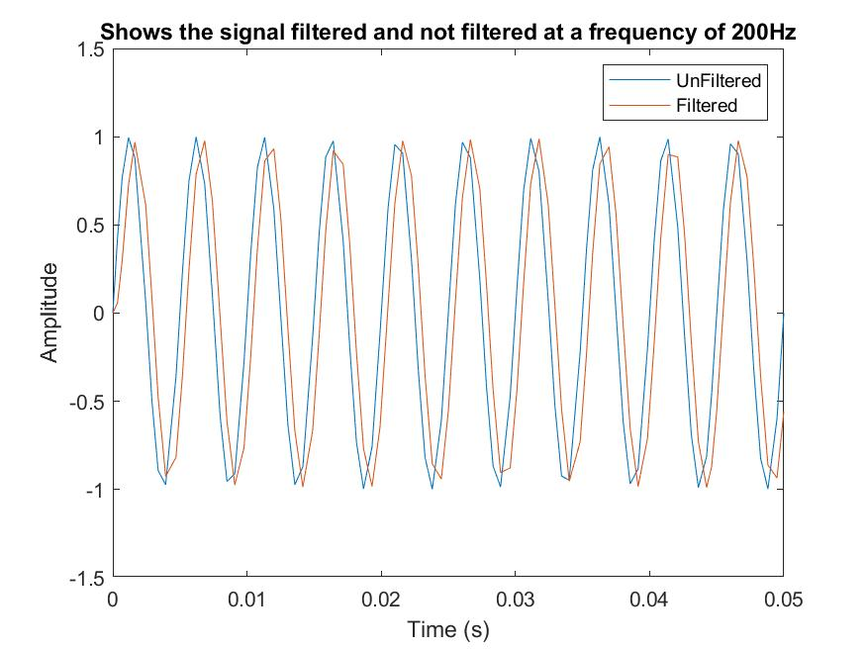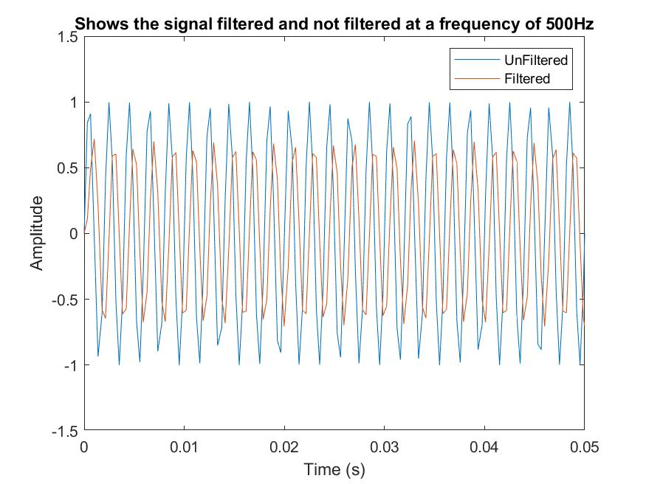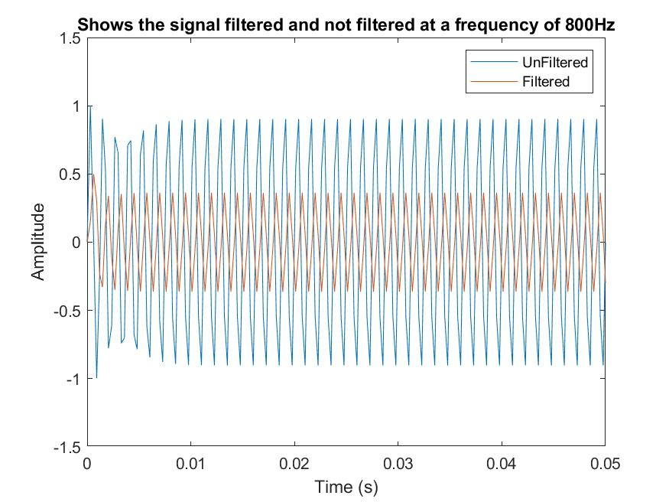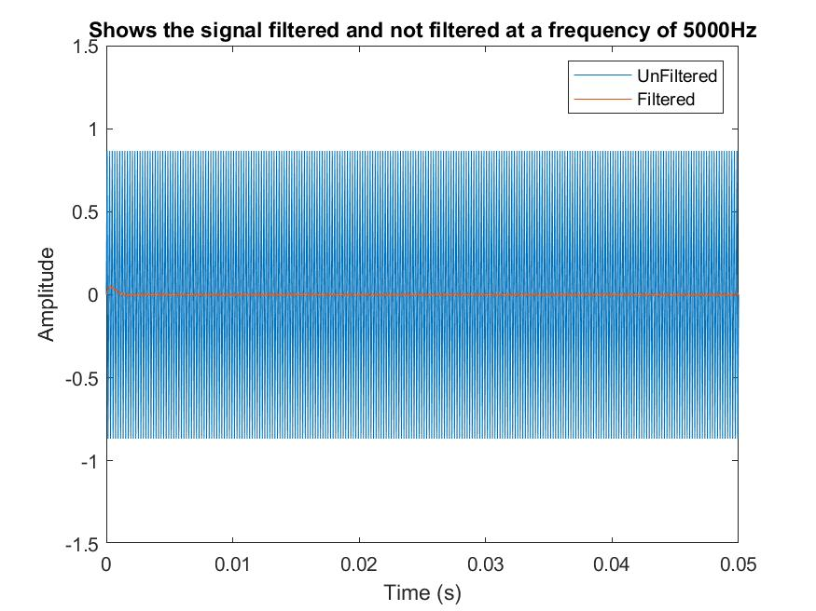

From Figure 6, it can be seen that the second order filter works, however, the amplitude at the cut off frequency, 500Hz (Top Right of Figure 6), shows that this order filter has a slow roll off, which is not desired. At 800Hz, above the cut off frequency, the amplitude is less than 0.5. At a frequency less than the cut off frequency, 200Hz, the amplitude is similar to the unfiltered version of the signal, however, here it is very apparent that there is a small delay, also known as the group delay. At 5000Hz, the signal is attenuated massively as desired to a very small signal.

Figure 7 shows the magnitude vs frequency (Left) of the second order Butterworth filter and semi-log of the x axis of magnitude vs frequency (Right). From Figure 7 (left) it can be seen that the roll of is very slow, starting at about 100Hz, getting to the cut off frequency at about -3dB as expected and -12dB at 1000Hz.

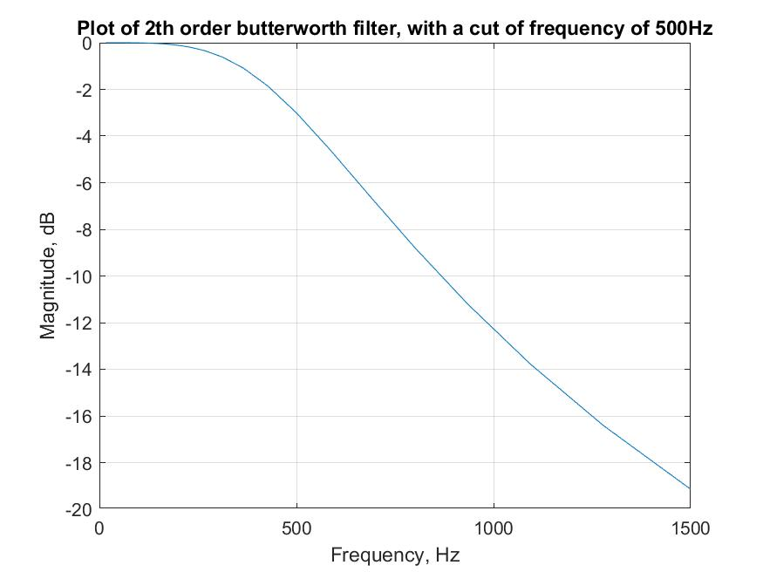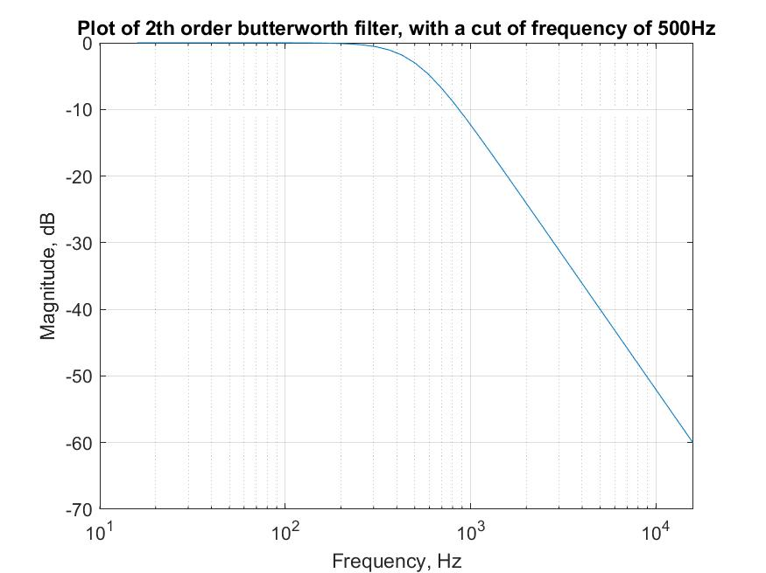

Figure - Shows the Frequency response of the 2nd Order Butterworth filter

Figure - Shows the group delay for the second order Butterworth filter

Figure 8 shows the group delay of the filter, across the frequency range the group delay is 2 samples. This delay can be observed in Figure 6 (Top Left), where the peaks of the unfiltered and filtered signal are at slightly different points. Because this is a linear phase response, the phase delay and group delay are the same, and the group delay is also constant, at 2 samples.

### Fourth Order Butterworth Filter

A fourth order butter worth filter was used for the anti-aliasing and reconstruction filters for the hardware system of (Pang, 2019).

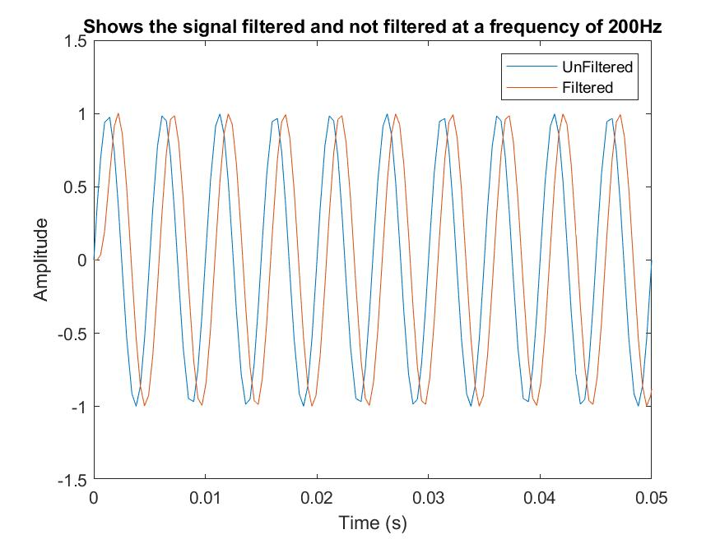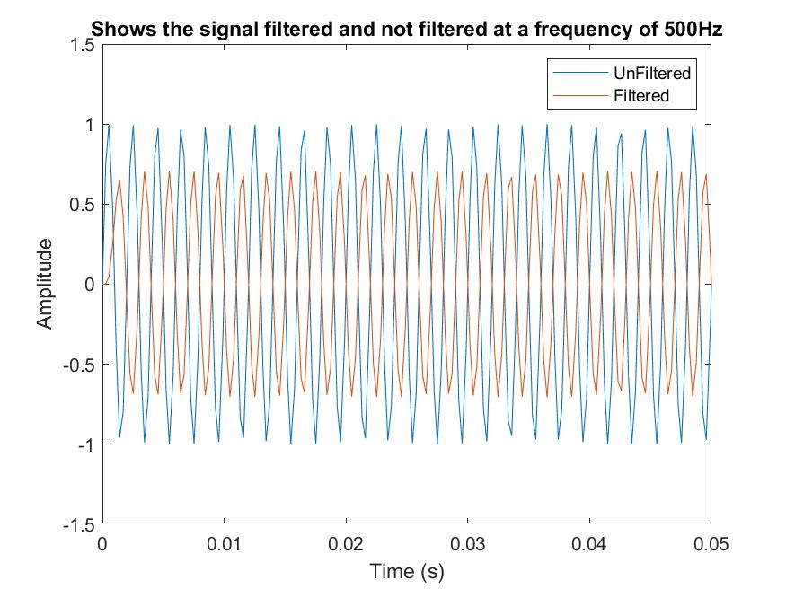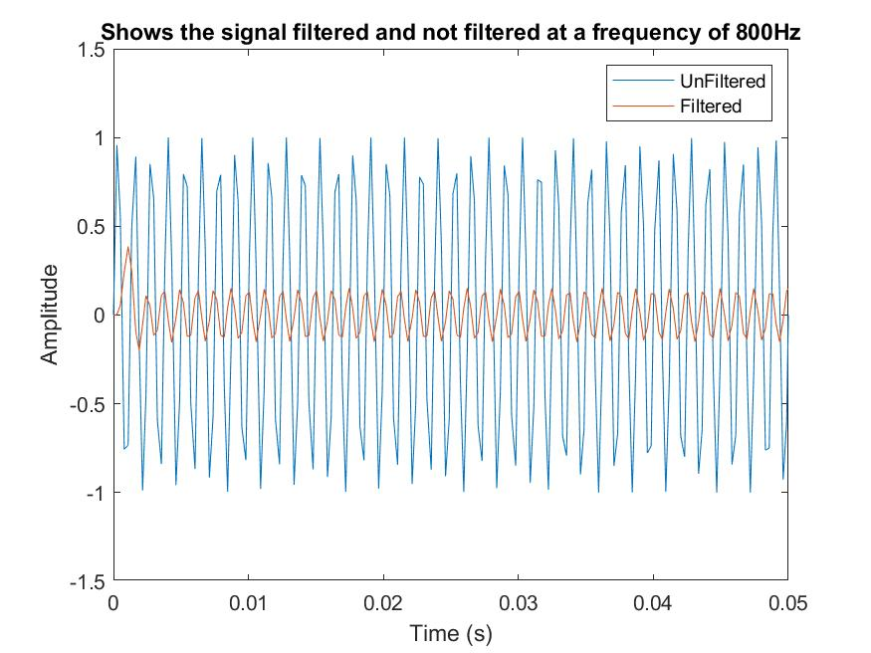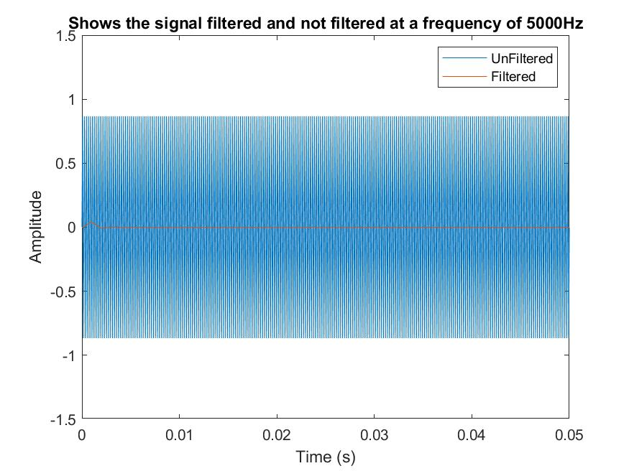

Figure - Shows the frequency response of a 4th order Butterworth filter at four different frequencies, 200Hz (Top Left), 500Hz (Top Right), 800Hz (Bottom Left), and 5000Hz (Bottom right)

The fourth order filter has a similar response to the second order response for Figure 9,Top Left and Right, where it differs is Figure 9, Bottom Left and Right, where the filtered signal is much more attenuated in comparison, in Figure 9 Bottom Right, the filtered signal is almost non-existent. This is a much better overall response compared to the second order Butterworth filter.

Figure - Shows the Frequency response of the 4th Order Butterworth filter

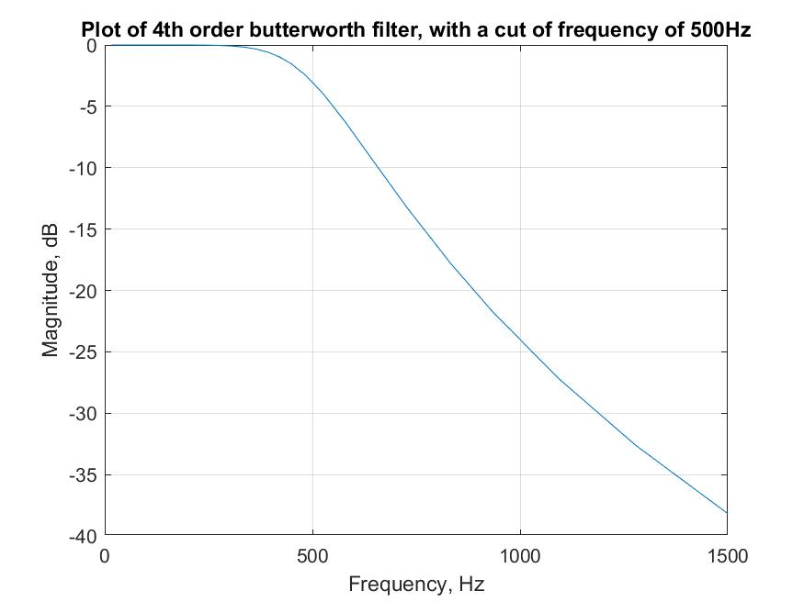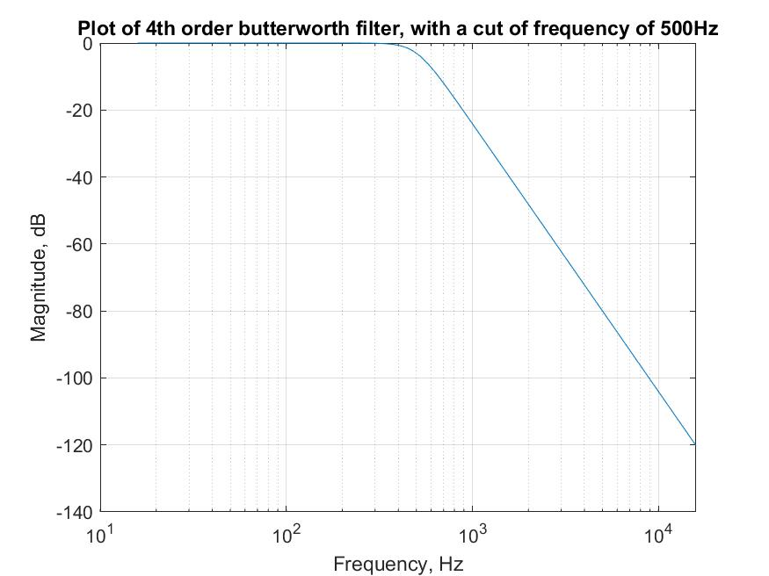

This can be seen even more from Figure 10, as the roll is steeper, which is more desired. The start of the roll off is at approximately 350-400Hz and reaches almost -25dB at 1000Hz.

Figure - Shows the group delay for the fourth order Butterworth filter

The response may be better than the second order filter, however the group delay is worse as seen in Figure 11, which shows a group delay of 4 samples. The longer the delay, the greater impact this has on the ability of the generated anti-noise.

### Fifth Order Butterworth Filter

In (Dennis, 2020), fifth order Butterworth filters are used.

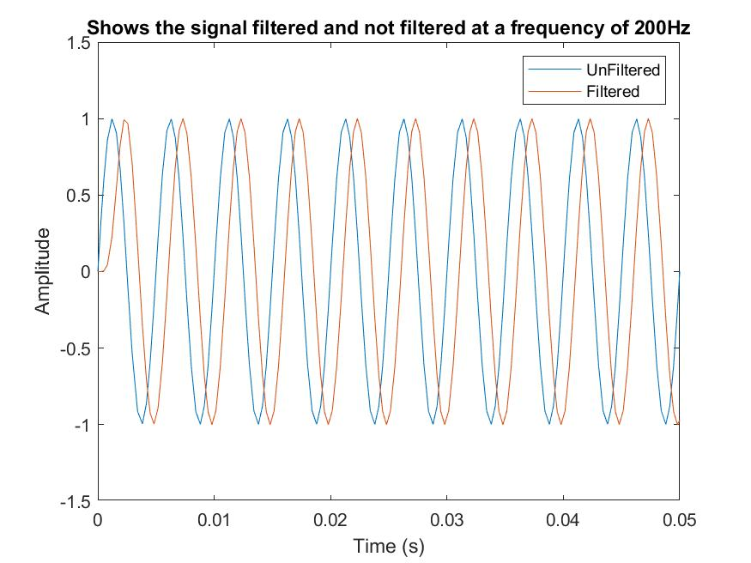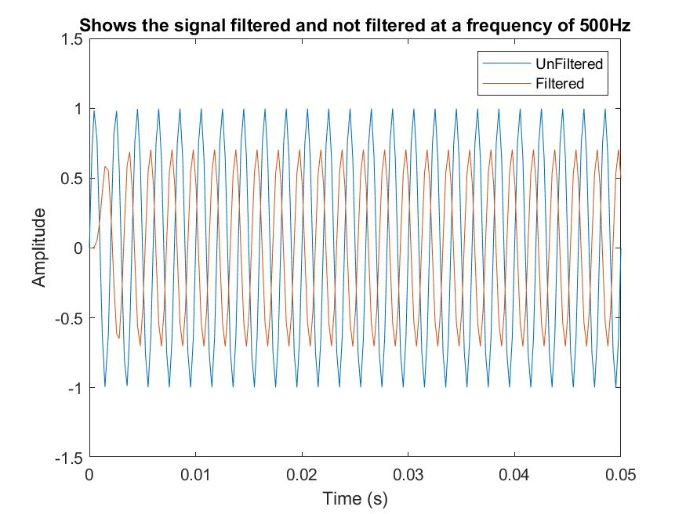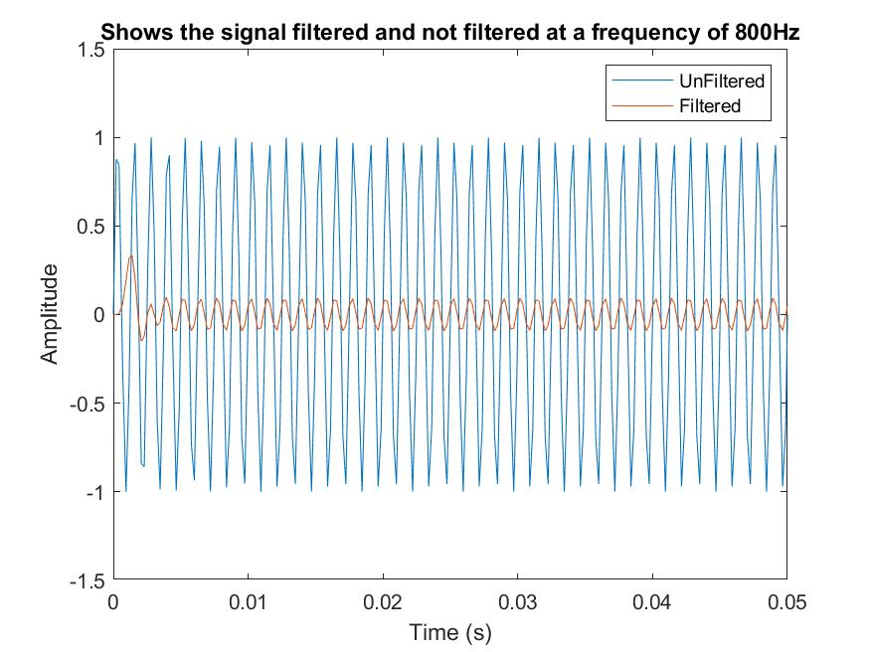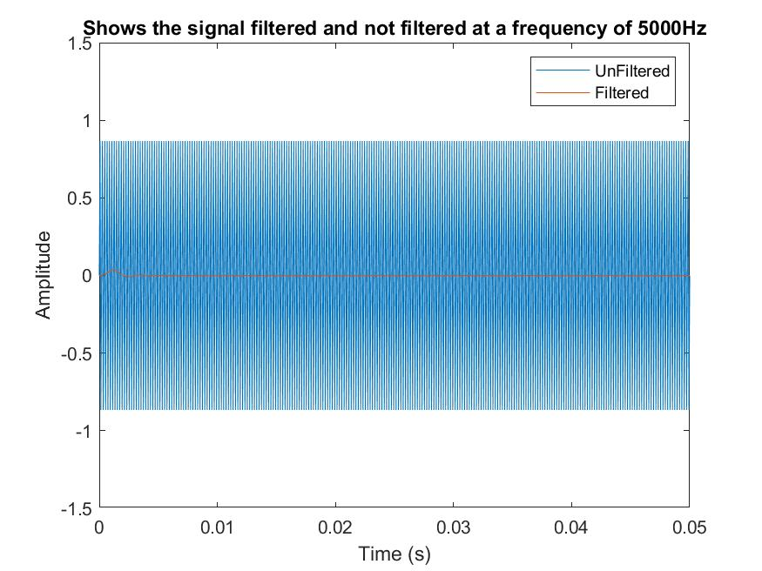

Figure - Shows the frequency response of a 5th order Butterworth filter at four different frequencies, 200Hz (Top Left), 500Hz (Top Right), 800Hz (Bottom Left), and 5000Hz (Bottom right)

From Figure 12, the same conclusions are drawn as were drawn from Figure 9. As the order increases, the roll off steepness also increases. Therefore it is desirable to have a high order Butterworth filter.

From Figure 12, Figure 9, and Figure 6, the 2nd, 4th, and 5th filters have similar responses at 500Hz, where the peak amplitude is approximately 0.7.

Figure - Shows the Frequency response of the 5th Order Butterworth filter

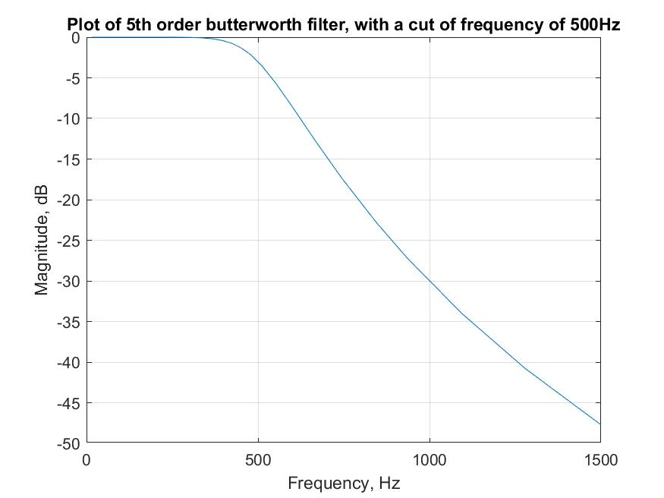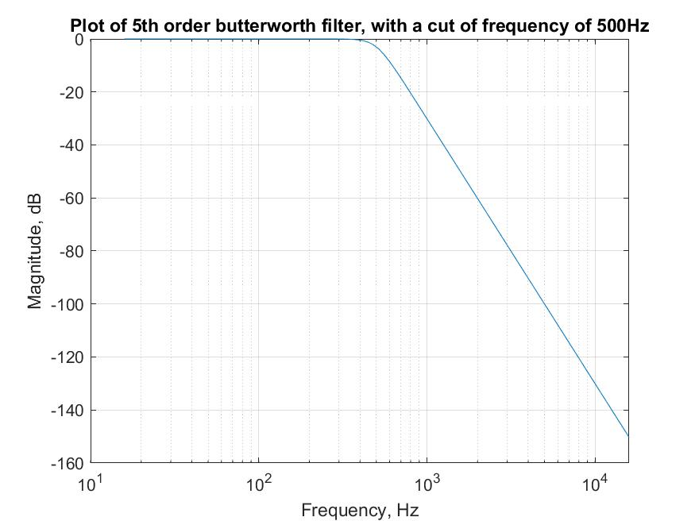

Again Figure 13 shows an improvement to the steepness of the roll off, where the start of the roll off happens close to the cut off frequency and 1000Hz the magnitude is -30dB.

Figure - Shows the group delay for the fifth order Butterworth filter

Figure 14 shows the group delay is now 5 samples, therefore effecting the ability of the algorithm more greatly.

### Eighth and Sixteenth Order Butterworth Filter

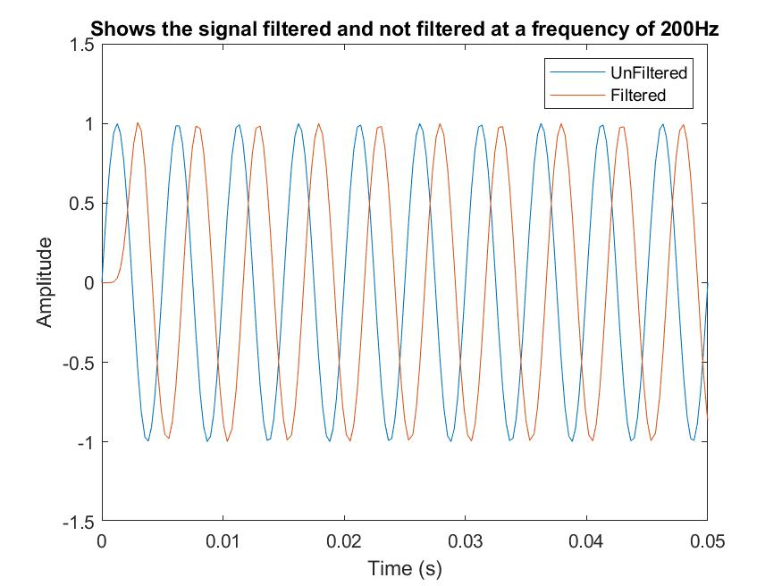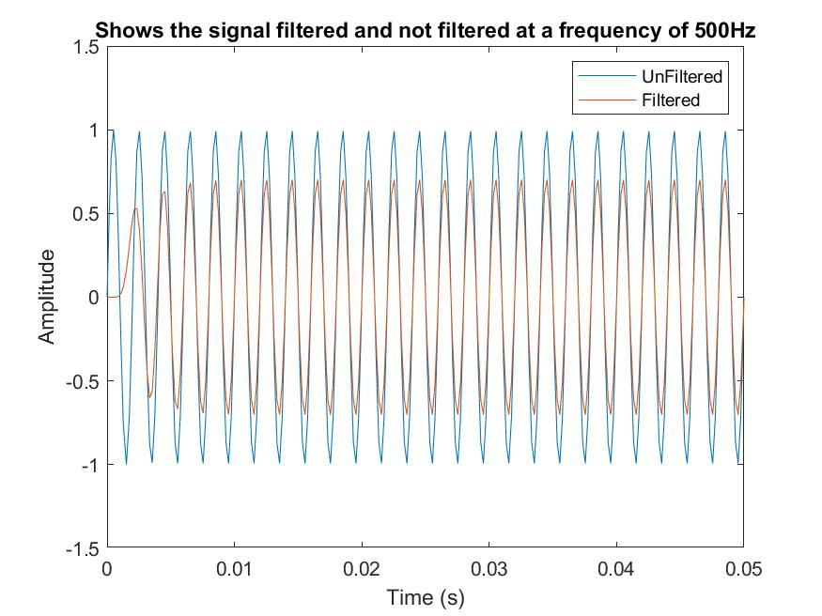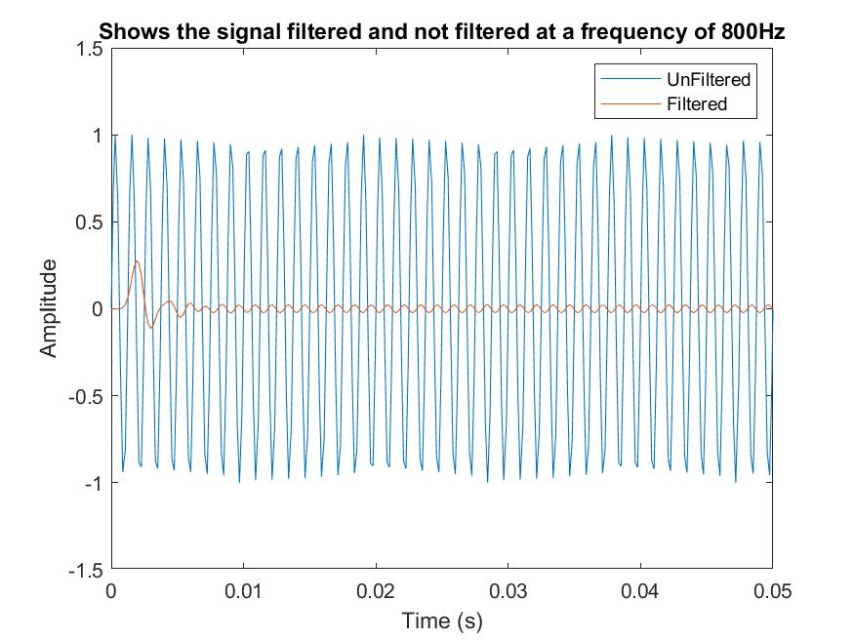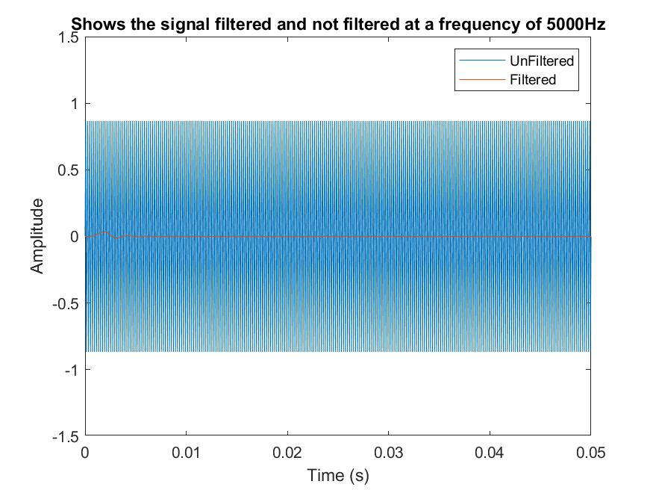

Figure - Shows the frequency response of an 8th order Butterworth filter at four different frequencies, 200Hz (Top Left), 500Hz (Top Right), 800Hz (Bottom Left), and 5000Hz (Bottom right)

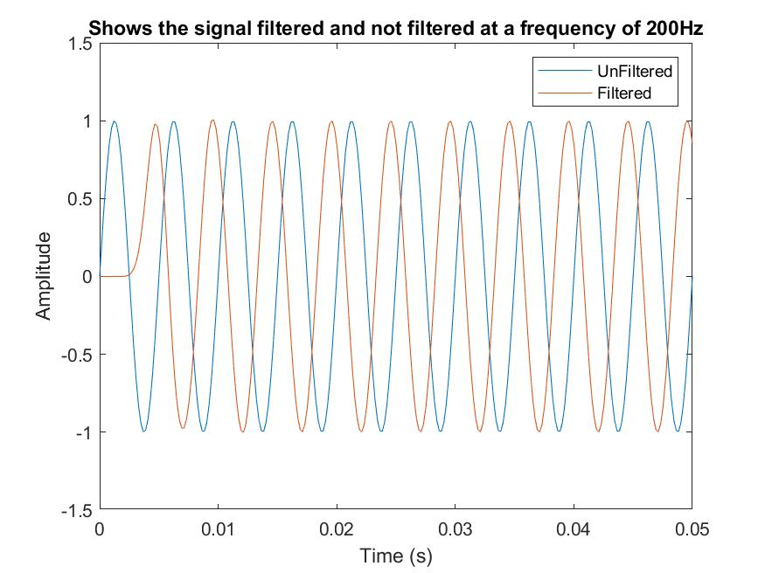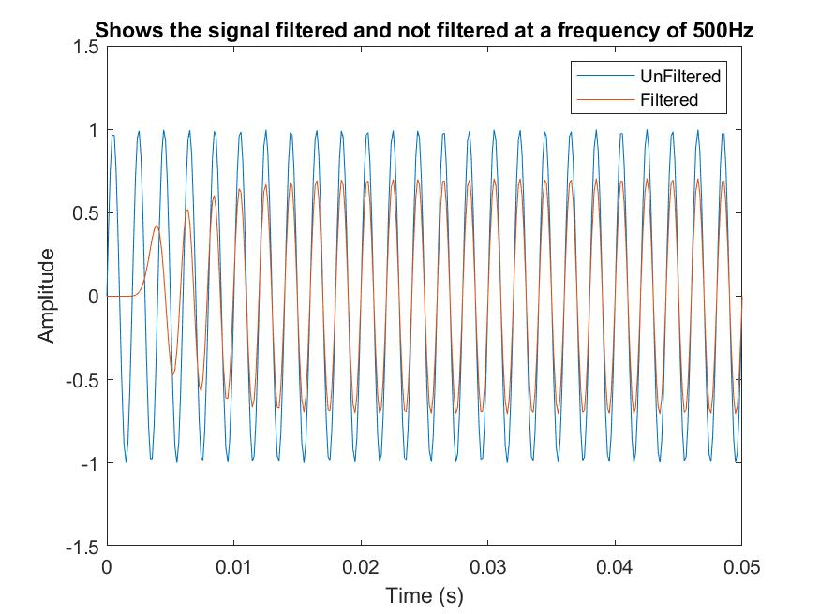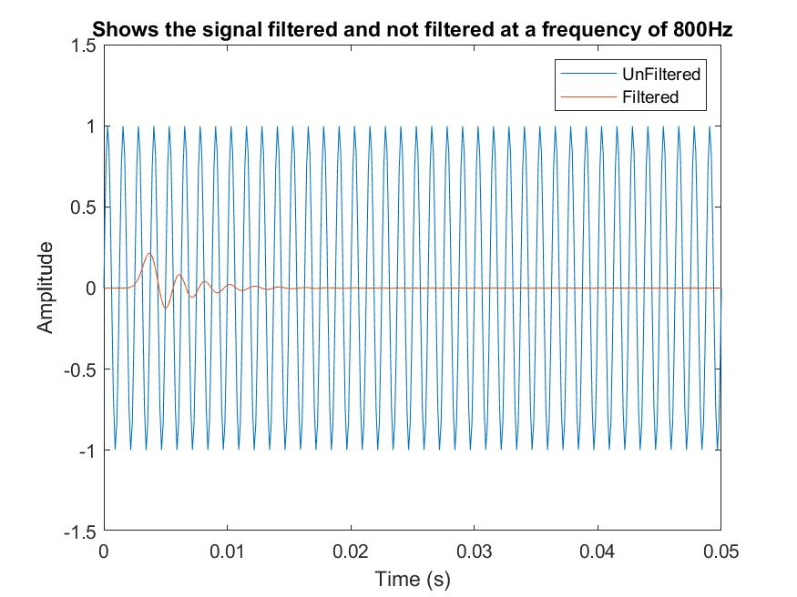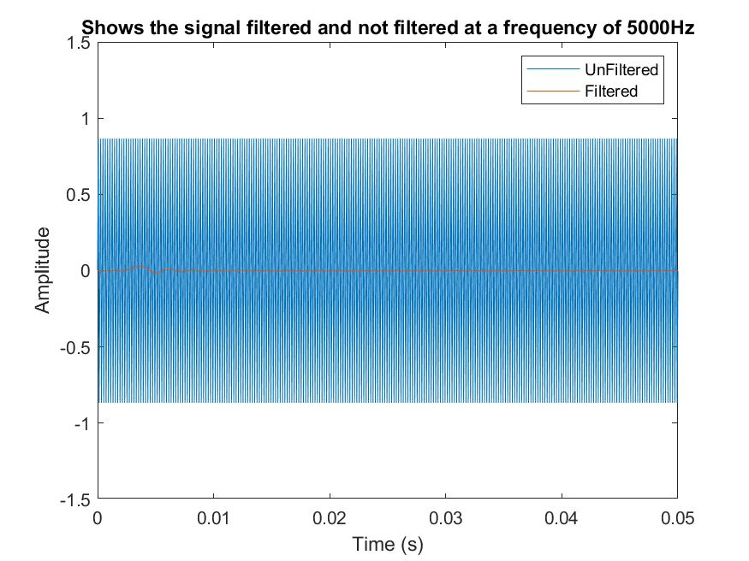

Figure - Shows the frequency response of a 16th order Butterworth filter at four different frequencies, 200Hz (Top Left), 500Hz (Top Right), 800Hz (Bottom Left), and 5000Hz (Bottom right)

Figure 15 shows the much greater response of the eighth order filter, which the amplitude at a frequency of 800Hz, being very close to zero. Figure 16 shows the sixteenth order filter which has a very similar frequency response to the eighth order filter. The delay is very significant as seen in both Figure 15, Top Left and Figure 16, Top Left, when compared to the previous delays of the other order filters.

Figure - Shows the Frequency response of the 8th Order Butterworth filter

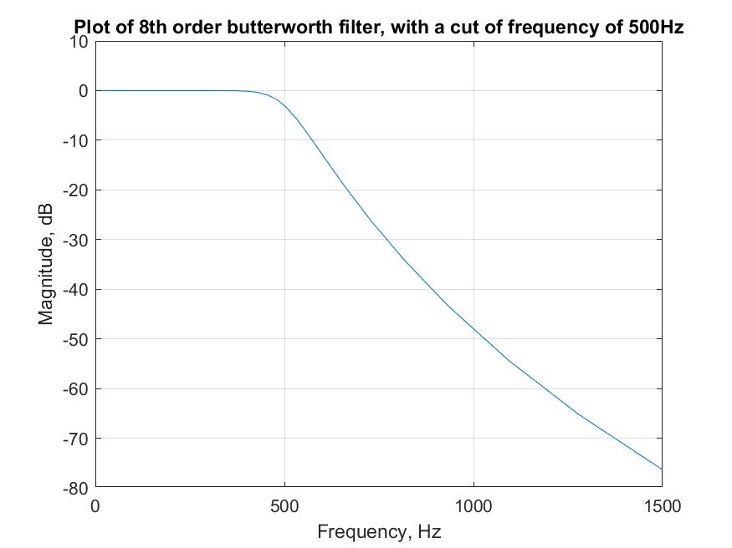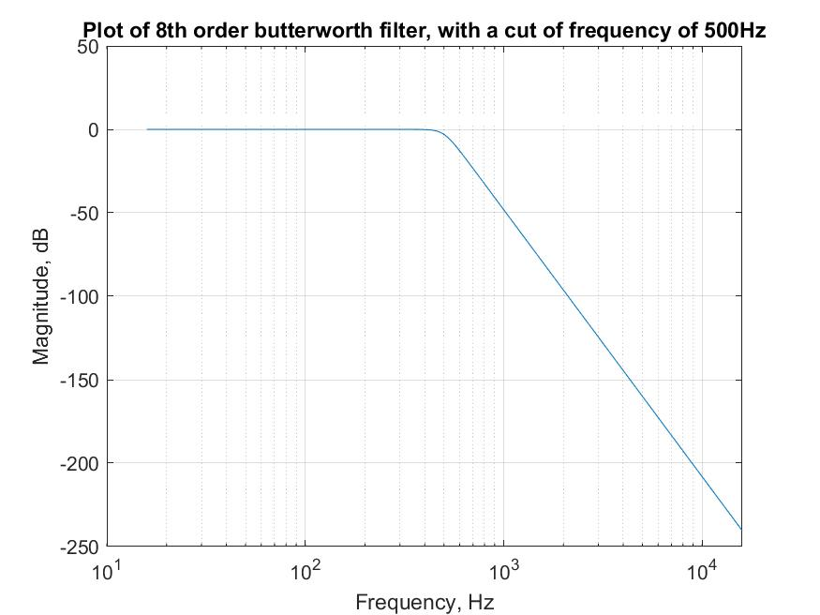

Figure - Shows the Frequency response of the 16th order Butterworth filter

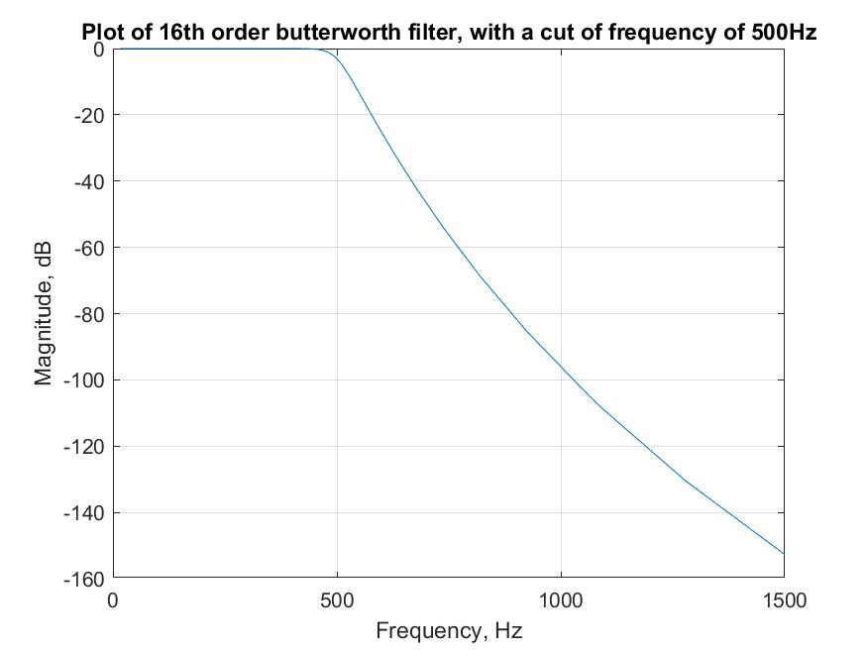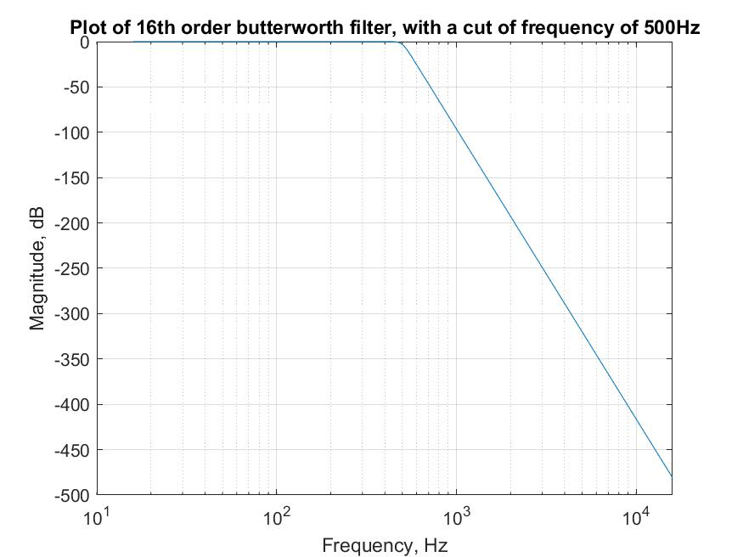

Figure 17 and Figure 18 show the frequency response of the 8th order and 16th order Butterworth filters respectively. The 16th order can be seen to have a better roll off as expected.

Figure - Shows the Group Delay of the 8th order filter (Left) and the 16th order filter (Right)

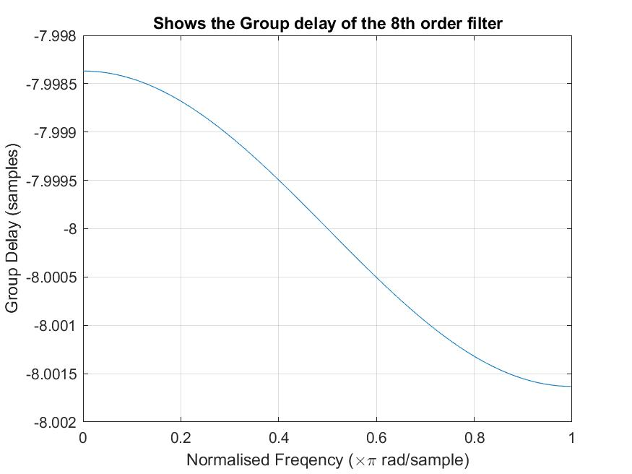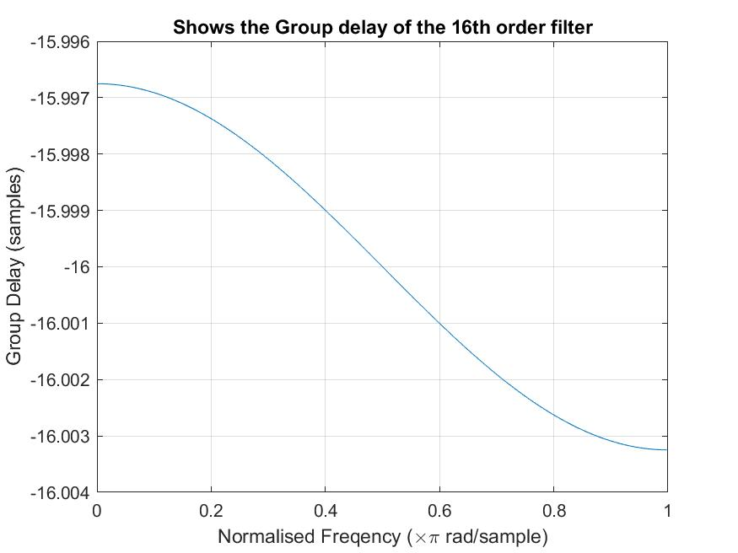

Figure 19 shows the group delays from the 8th order and 16th order filters; they are 8 samples and 16 samples respectively.

### Simulink Summary

From the simulations it is clear to see that the higher the order the better the frequency response is, however, there is a trade off with the group delay. The group delay seems to follow a pattern of nth order filter has a group delay of n samples. Therefore it is unrealistic to have a large number order Butterworth filter within an ANC system operating in a small environment. A fourth order Butterworth filter should be sufficient for this application, further testing could be done into the effect the higher order has on the system.

A 16th order Butterworth filter is not recommended for this project, against recommendations from (Ete, 2016), but a project with a larger budget for several different filters could attempt use of the 16th order filter and evaluate the use in an ANC system better than the simulations.

## LT Spice Simulations

Using the components calculated in the MATLAB script using method 1 and 2, these values are then converted to standard values and simulated within LT Spice. The stages are cascaded in rising values of the Q factor.

### Second Order Butterworth Filter

Figure - Shows the frequency response of the 2nd order Butterworth filter using both method 1 (Blue) and method 2 (Green)

From Figure 20, the frequency response of both method 1 and 2 are very similar. The roll off for this filter is very slow as expected.

### Fourth Order Butterworth Filter

Figure - Shows the frequency response of the 4th order Butterworth filter using both method 1 (Green) and method 2 (Blue)

Again both methods have an almost exact same frequency response for the fourth order Butterworth filter. The roll off for this is also much better.

### Fifth Order Butterworth Filter

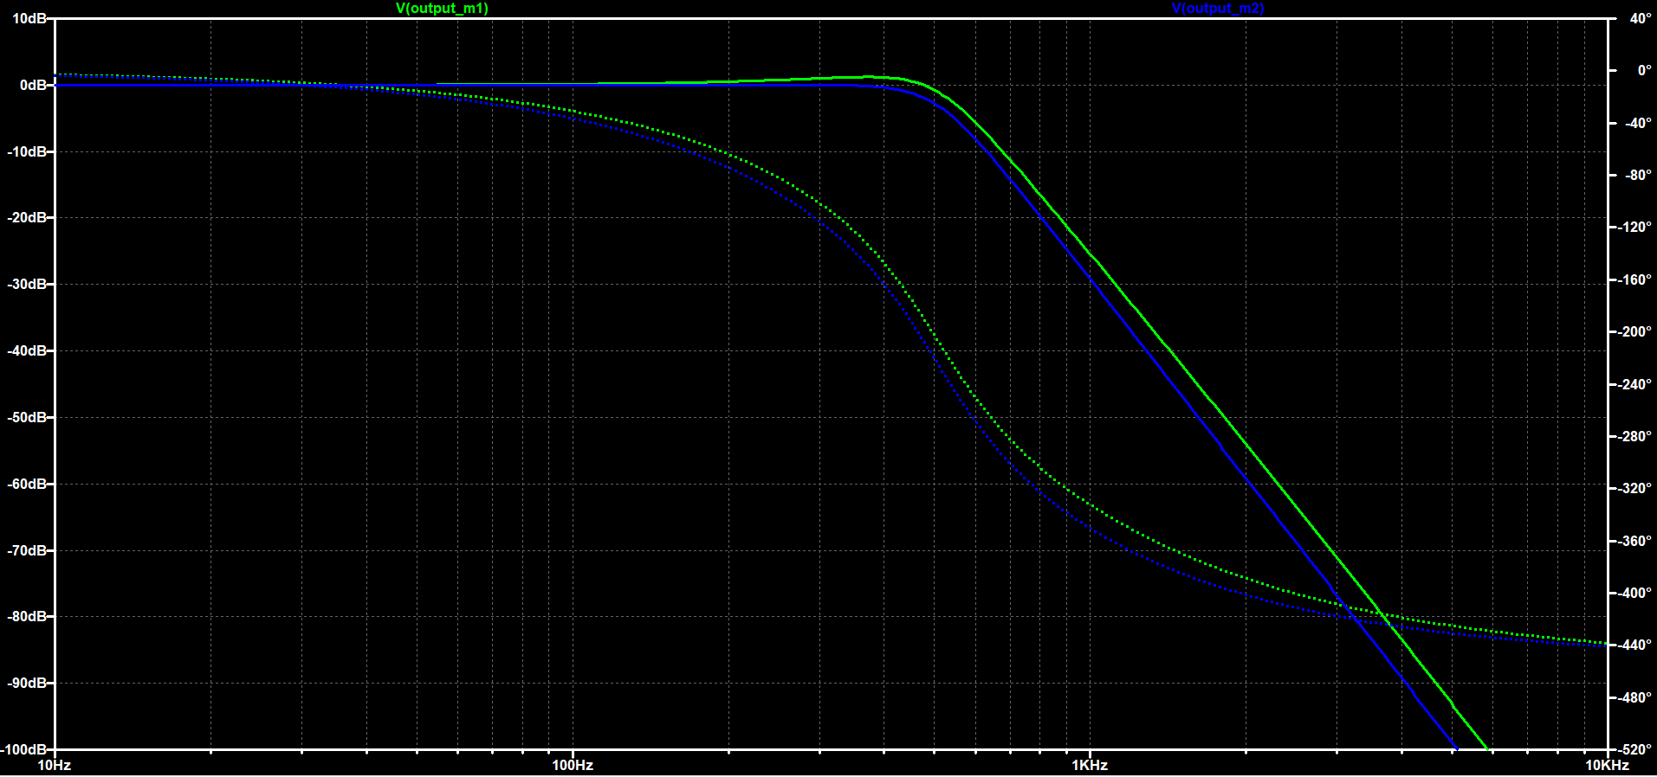

Figure - Shows the frequency response of the 5th order Butterworth filter using both method 1 (Green) and method 2 (Blue)

From Figure 22, it can be seen that the frequency response from method 2, blue line, is more ideal than the response using method 1, green line. The green line increases slightly at frequencies between 300Hz and 500Hz, which is not what is desired with these filters. The blue line also has a steeper roll off and therefore will attenuate signals in this region more greatly than method 1.

### Eighth Order Butterworth Filter

Figure - Shows the frequency response of the 8th order Butterworth filter using both method 1 (Green) and method 2 (Blue)

Figure 23 shows the frequency response of the 8th order filter, here the cut off frequency is much closer to the desired cut off frequency of 500Hz using method 2 rather than method 1. However both methods have the same roll off gradient.

### Sixteenth Order Butterworth Filter

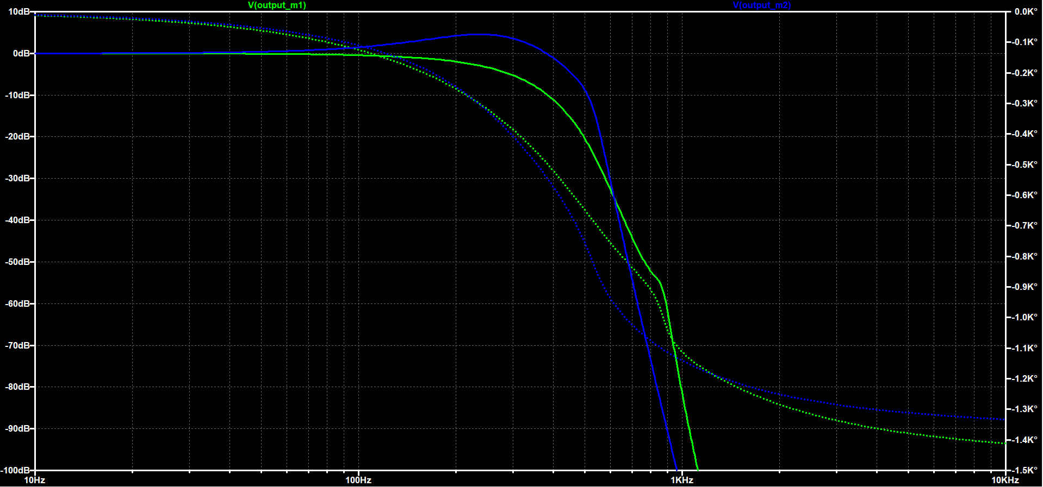

Figure - Shows the frequency response of the 16th order Butterworth filter using both method 1 (Green) and method 2 (Blue)

Figure 24 shows the 16th order Butterworth filter frequency response. These frequency responses are much closer to that of the ideal low pass filter. However, method 2 has a slight rise just before the cut of frequency which is not desired but this method closer to the desired cut off frequency.

Method 1 also has a slight change in its response, with a slight deviation between -50dB and -60db which is not usual. The gradient of the roll off is much steeper for method 2 compared to method 1. Of the orders simulated, the 16th order filter has the most similar frequency response as the ideal filter frequency response, however, will also have the greatest group delay. The group delay will affect the algorithm and impact the distance between the microphones are loudspeakers.

### LT Spice Simulation Summary

From these simulations method 2 for calculating the components has a more desired response compared to method 1, however, these are all simulations and further testing should take place with these filters implemented.

The deviation in Figure 24 is an anomaly, further information gathered to the reason for this would be beneficial, to understand if greater care needs to take place when selecting components to remove this.

# References

Dennis, 2020. *‘Real-Time Implementation of Filtered-x Least Mean Squared Algorithm for an Active Noise Control System,* s.l.: s.n.

Ete, P., 2016. *‘Design, Build and Implementation of Variable Frequency Active Low Pass Filter for Audio Amplification in Active Noise Control System,* s.l.: s.n.

Mancini, R., 2003. Op Amps for Everyone; Second Edition . In: R. Mancini, ed. s.l.:Newnes, p. Chapter 16.

McClure, D. L., n.d. *resistorsandcaps.pdf.* [Online]   
Available at: https://ecee.colorado.edu/~mcclurel/resistorsandcaps.pdf  
[Accessed 25 5 2021].

Pang, K., 2019. *Towards Design and Implementation of an Active Noise Control System inside the Car Cabin,* s.l.: s.n.

# Appendices

## Butterworth Filter MATLAB Scripts

### Filter Poles.m

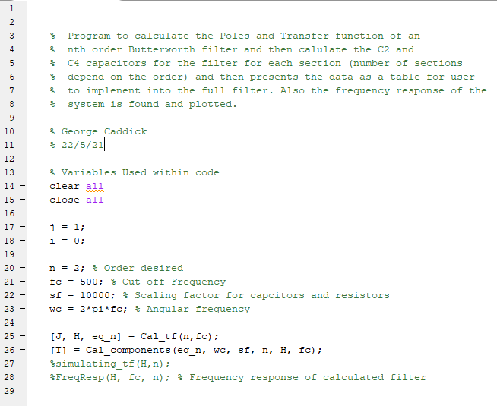

### Cal_tf.m

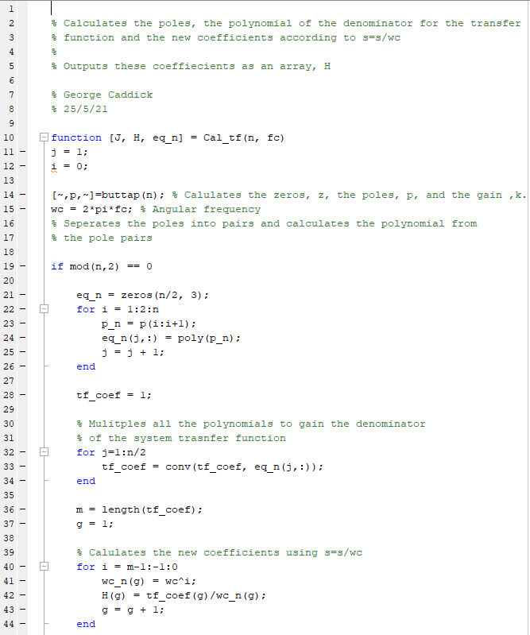

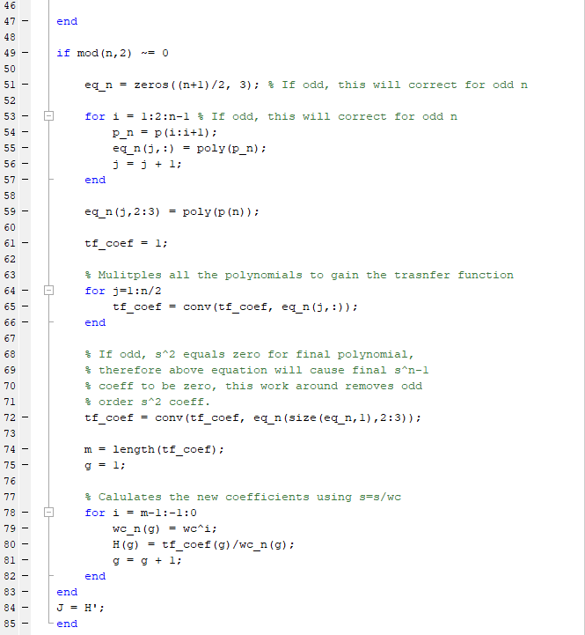

### Cal_components.m

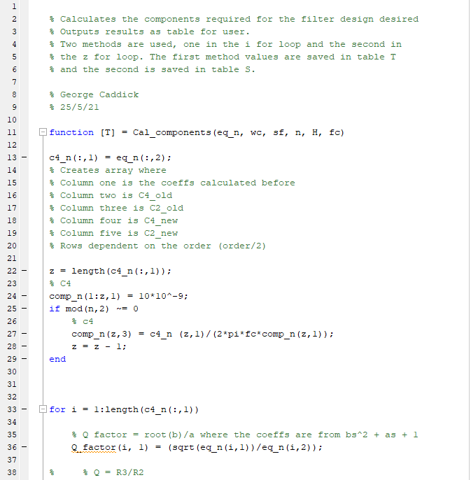

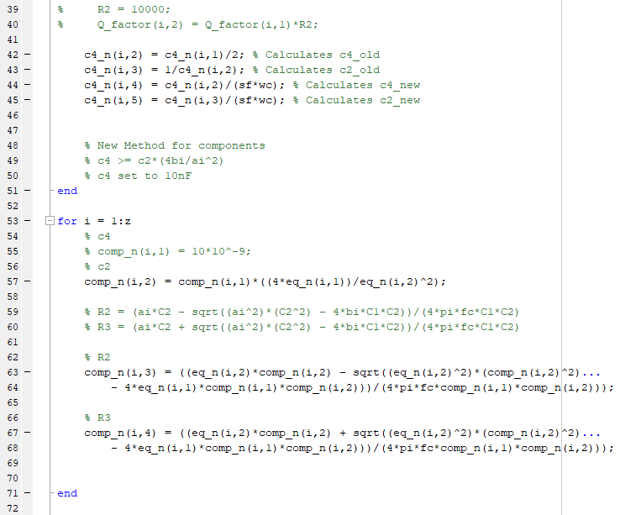

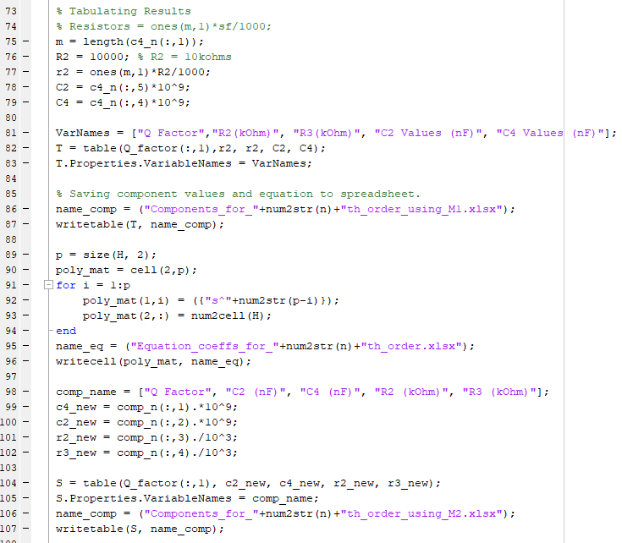

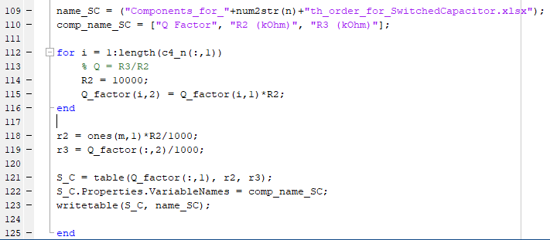

### FreqResp.m

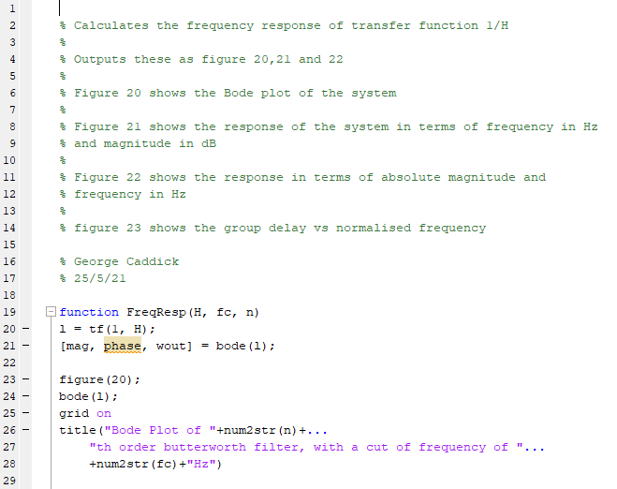

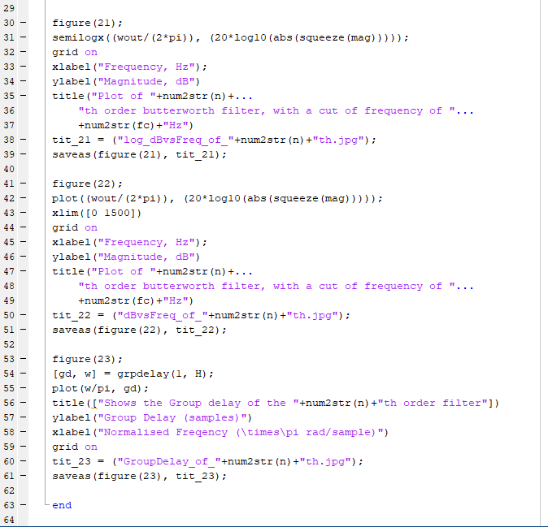

### simulating_tf.m

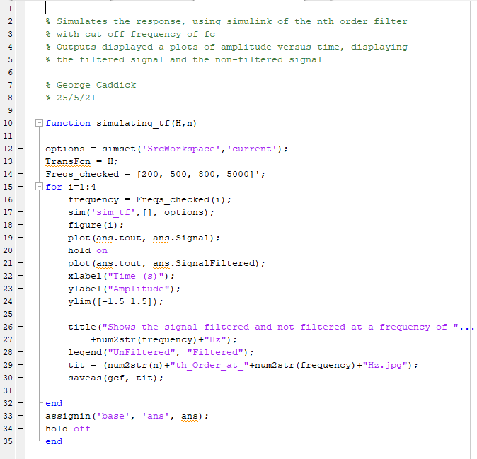

### sim_tf.slx

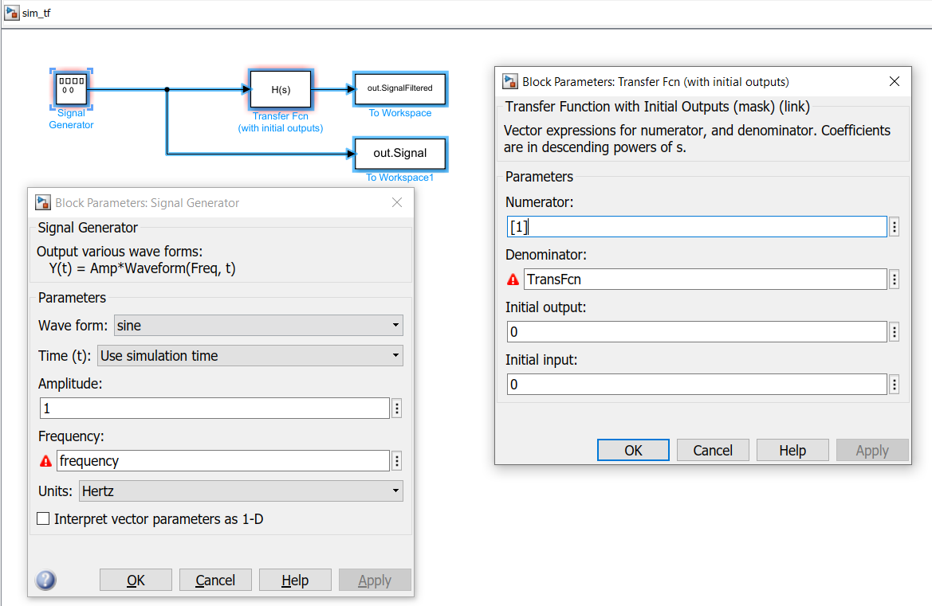

## MATLAB Results

### Component Values (Method 1 and 2)

#### Method One

|  |  |  |  |  |  |
| --- | --- | --- | --- | --- | --- |
| Second Order | Q Factor | R2(kOhm) | R3(kOhm) | C2 Values (nF) | C4 Values (nF) |
|  | 0.707107 | 10 | 10 | 45.01582 | 22.5079079 |
|  |  |  |  |  |  |
| Fourth Order | Q Factor | R2(kOhm) | R3(kOhm) | C2 Values (nF) | C4 Values (nF) |
|  | 1.306563 | 10 | 10 | 83.17838 | 12.18119198 |
|  | 0.541196 | 10 | 10 | 34.45361 | 29.40799888 |
|  |  |  |  |  |  |
| Fifth Order | Q Factor | R2(kOhm) | R3(kOhm) | C2 Values (nF) | C4 Values (nF) |
|  | 1.618034 | 10 | 10 | 103.0072 | 9.836316431 |
|  | 0.618034 | 10 | 10 | 39.34527 | 25.75181074 |
|  | 0 | 10 | 10 | 63.66198 | 15.91549431 |
|  |  |  |  |  |  |
| Eighth Order | Q Factor | R2(kOhm) | R3(kOhm) | C2 Values (nF) | C4 Values (nF) |
|  | 2.562915 | 10 | 10 | 163.1603 | 6.20991782 |
|  | 0.899976 | 10 | 10 | 57.29427 | 17.68434976 |
|  | 0.601345 | 10 | 10 | 38.2828 | 26.46649977 |
|  | 0.509796 | 10 | 10 | 32.45459 | 31.2193651 |
|  |  |  |  |  |  |
| Sixteenth Order | Q Factor | R2(kOhm) | R3(kOhm) | C2 Values (nF) | C4 Values (nF) |
|  | 5.101149 | 10 | 10 | 324.7492 | 3.119982478 |
|  | 1.722447 | 10 | 10 | 109.6544 | 9.240048258 |
|  | 1.060678 | 10 | 10 | 67.52484 | 15.00502416 |
|  | 0.788155 | 10 | 10 | 50.17548 | 20.19336541 |
|  | 0.646822 | 10 | 10 | 41.17795 | 24.60568694 |
|  | 0.566944 | 10 | 10 | 36.09278 | 28.07242573 |
|  | 0.522499 | 10 | 10 | 33.26329 | 30.46035694 |
|  | 0.502419 | 10 | 10 | 31.98501 | 31.67771371 |

#### Method Two

|  |  |  |  |  |  |
| --- | --- | --- | --- | --- | --- |
| Second Order | Q Factor | C2 (nF) | C4 (nF) | R2 (kOhm) | R3 (kOhm) |
|  | 0.707107 | 20 | 10 | 22.50791 | 22.50791 |
|  |  |  |  |  |  |
| Fourth Order | Q Factor | C2 (nF) | C4 (nF) | R2 (kOhm) | R3 (kOhm) |
|  | 1.306563 | 68.28427 | 10 | 12.18119 | 12.18119 |
|  | 0.541196 | 11.71573 | 10 | 29.408 | 29.408 |
|  |  |  |  |  |  |
| Fifth Order | Q Factor | C2 (nF) | C4 (nF) | R2 (kOhm) | R3 (kOhm) |
|  | 1.618034 | 104.7214 | 10 | 9.836316 | 9.836316 |
|  | 0.618034 | 15.27864 | 10 | 25.75181 | 25.75181 |
|  | 0 | 0 | 10 | 31.83099 | 0 |
|  |  |  |  |  |  |
| Eighth Order | Q Factor | C2 (nF) | C4 (nF) | R2 (kOhm) | R3 (kOhm) |
|  | 2.562915 | 262.7414 | 10 | 6.209918 | 6.209918 |
|  | 0.899976 | 32.39829 | 10 | 17.68435 | 17.68435 |
|  | 0.601345 | 14.46463 | 10 | 26.4665 | 26.4665 |
|  | 0.509796 | 10.39566 | 10 | 31.21937 | 31.21937 |
|  |  |  |  |  |  |
| Sixteenth Order | Q Factor | C2 (nF) | C4 (nF) | R2 (kOhm) | R3 (kOhm) |
|  | 5.101149 | 1040.869 | 10 | 3.119982 | 3.119982 |
|  | 1.722447 | 118.673 | 10 | 9.240048 | 9.240048 |
|  | 1.060678 | 45.00149 | 10 | 15.00502 | 15.00502 |
|  | 0.788155 | 24.84751 | 10 | 20.19337 | 20.19337 |
|  | 0.646822 | 16.73514 | 10 | 24.60569 | 24.60569 |
|  | 0.566944 | 12.85702 | 10 | 28.07243 | 28.07243 |
|  | 0.522499 | 10.92019 | 10 | 30.46036 | 30.46036 |
|  | 0.502419 | 10.09701 | 10 | 31.67771 | 31.67771 |

### Switched Capacitor Values

|  |  |  |  |
| --- | --- | --- | --- |
| Second Order | Q Factor | R2 (kOhm) | R3 (kOhm) |
|  | 0.707107 | 100 | 70.71068 |
|  |  |  |  |
| Fourth Order | Q Factor | R2 (kOhm) | R3 (kOhm) |
|  | 1.306563 | 100 | 130.6563 |
|  | 0.541196 | 100 | 54.11961 |
|  |  |  |  |
| Fifth Order | Q Factor | R2 (kOhm) | R3 (kOhm) |
|  | 1.618034 | 100 | 161.8034 |
|  | 0.618034 | 100 | 61.8034 |
|  | 0 | 100 | 0 |
|  |  |  |  |
| Eighth Order | Q Factor | R2 (kOhm) | R3 (kOhm) |
|  | 2.562915 | 100 | 256.2915 |
|  | 0.899976 | 100 | 89.99762 |
|  | 0.601345 | 100 | 60.13449 |
|  | 0.509796 | 100 | 50.97956 |
|  |  |  |  |
| Sixteenth Order | Q Factor | R2 (kOhm) | R3 (kOhm) |
|  | 5.101149 | 100 | 510.1149 |
|  | 1.722447 | 100 | 172.2447 |
|  | 1.060678 | 100 | 106.0678 |
|  | 0.788155 | 100 | 78.81546 |
|  | 0.646822 | 100 | 64.68218 |
|  | 0.566944 | 100 | 56.6944 |
|  | 0.522499 | 100 | 52.24986 |
|  | 0.502419 | 100 | 50.24193 |

### Transfer Function Coefficients

|  |  |  |  |
| --- | --- | --- | --- |
| Second Order | s^2 | s^1 | s^0 |
|  | 1.01E-07 | 0.00045 | 1 |

|  |  |  |  |  |  |
| --- | --- | --- | --- | --- | --- |
| Fourth Order | s^4 | s^3 | s^2 | s^1 | s^0 |
|  | 1.03E-14 | 8.43E-11 | 3.46E-07 | 0.000832 | 1 |

|  |  |  |  |  |  |  |
| --- | --- | --- | --- | --- | --- | --- |
| Fifth Order | s^5 | s^4 | s^3 | s^2 | s^1 | s^0 |
|  | 3.27E-18 | 3.32E-14 | 1.69E-10 | 5.31E-07 | 0.00103 | 1 |

|  |  |  |  |  |  |  |  |  |  |
| --- | --- | --- | --- | --- | --- | --- | --- | --- | --- |
| Eighth Order | s^8 | s^7 | s^6 | s^5 | s^4 | s^3 | s^2 | s^1 | s^0 |
|  | 1.05E-28 | 1.7E-24 | 1.37E-20 | 7.14E-17 | 2.64E-13 | 7.05E-10 | 1.33E-06 | 0.001632 | 1 |

|  |  |  |  |  |  |  |  |  |  |  |  |  |  |  |  |  |  |
| --- | --- | --- | --- | --- | --- | --- | --- | --- | --- | --- | --- | --- | --- | --- | --- | --- | --- |
| Sixteenth Order | s^16 | s^15 | s^14 | s^13 | s^12 | s^11 | s^10 | s^9 | s^8 | s^7 | s^6 | s^5 | s^4 | s^3 | s^2 | s^1 | s^0 |
|  | 1.11E-56 | 3.56E-52 | 5.71E-48 | 6.06E-44 | 4.76E-40 | 2.93E-36 | 1.46E-32 | 6.01E-29 | 2.07E-25 | 5.94E-22 | 1.42E-18 | 2.82E-15 | 4.51E-12 | 5.67E-09 | 5.27E-06 | 0.003247 | 1 |

## LT Spice Circuits

### Nth order

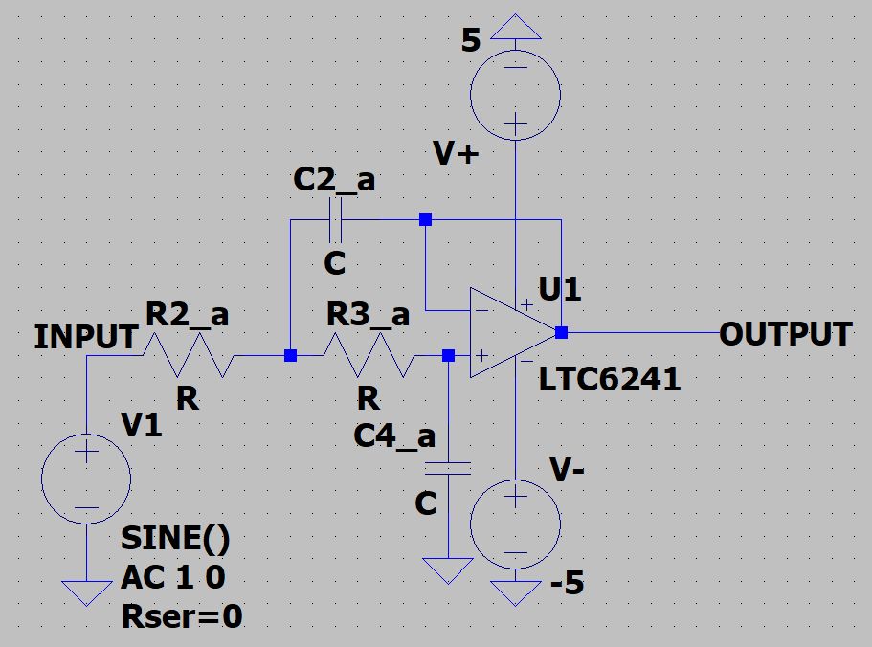

### Second Order Butterworth Filter

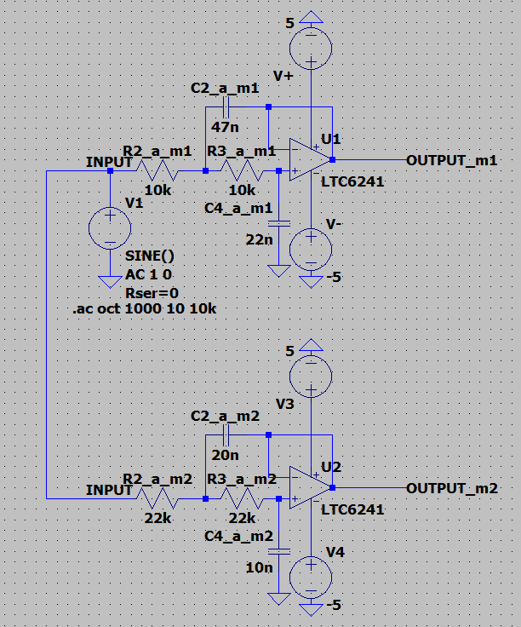

### Fourth Order Butterworth Filter

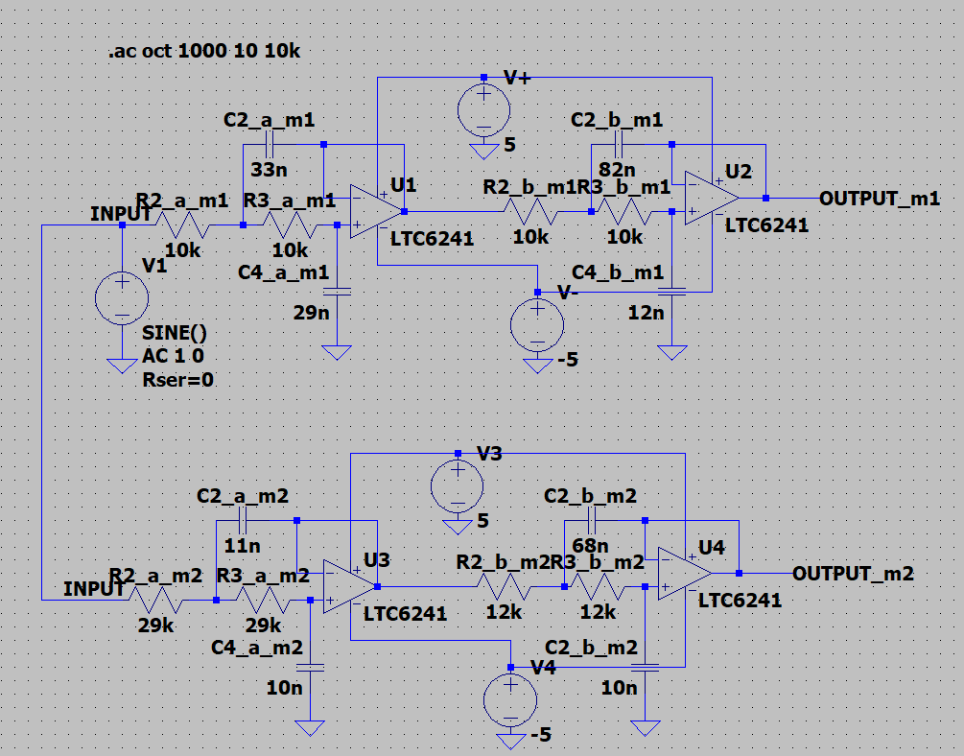

### Fifth Order Butterworth Filter

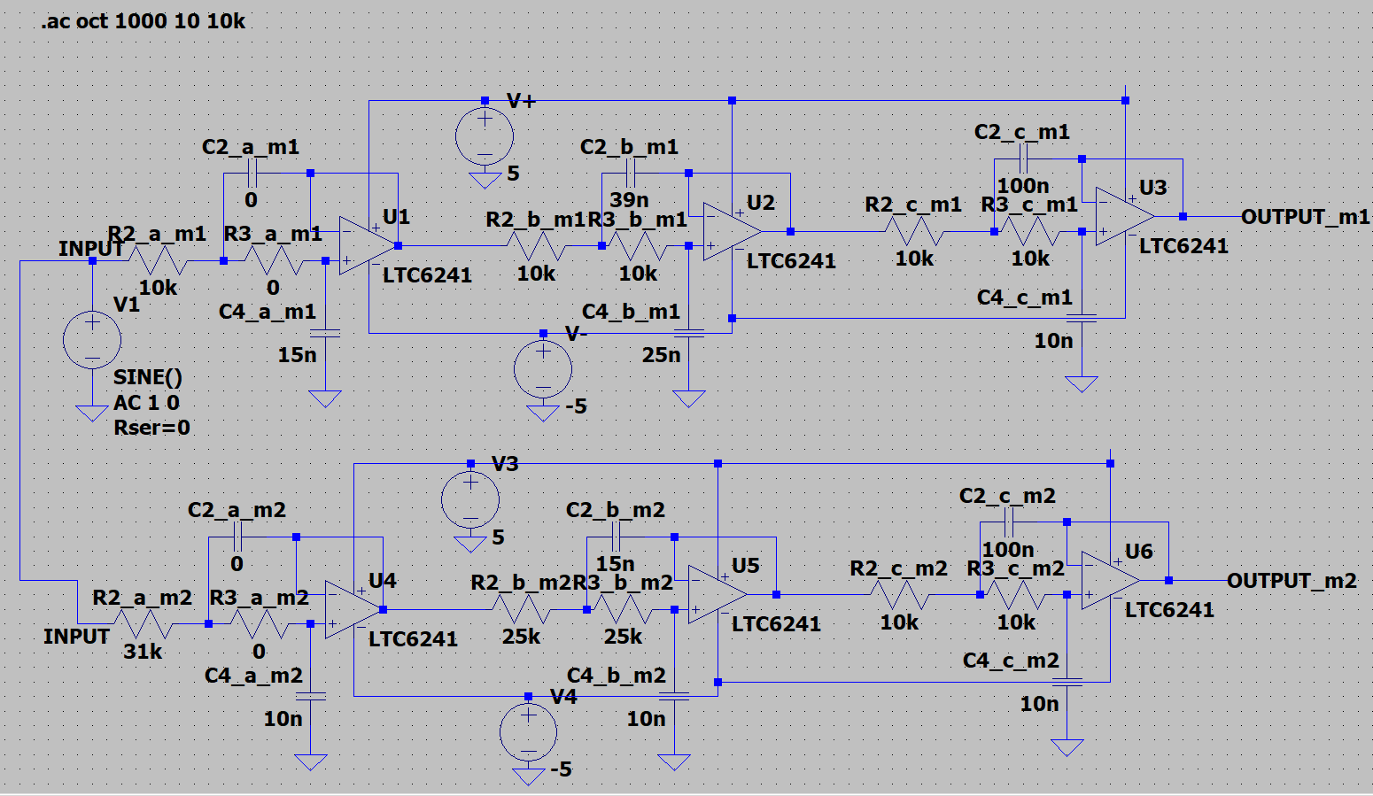

### Eighth Order Butterworth Filter

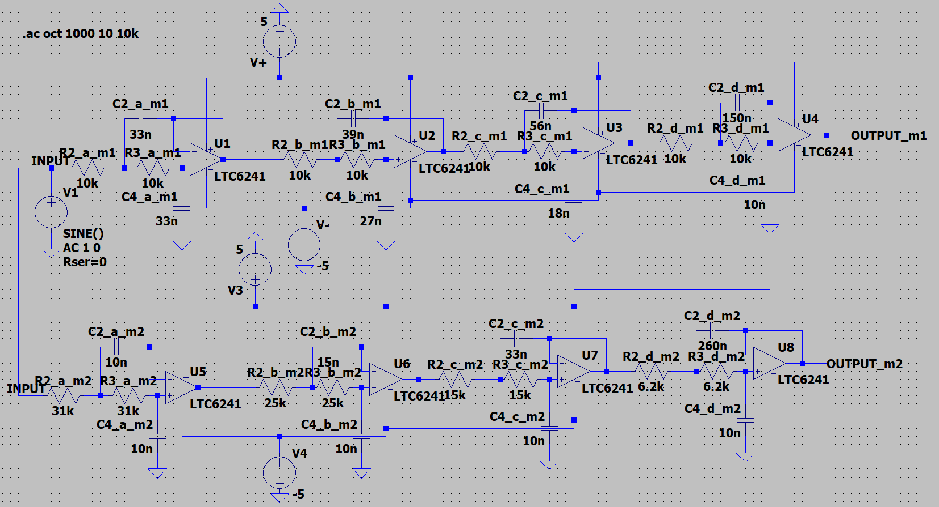

### Sixteenth Order Butterworth Filter

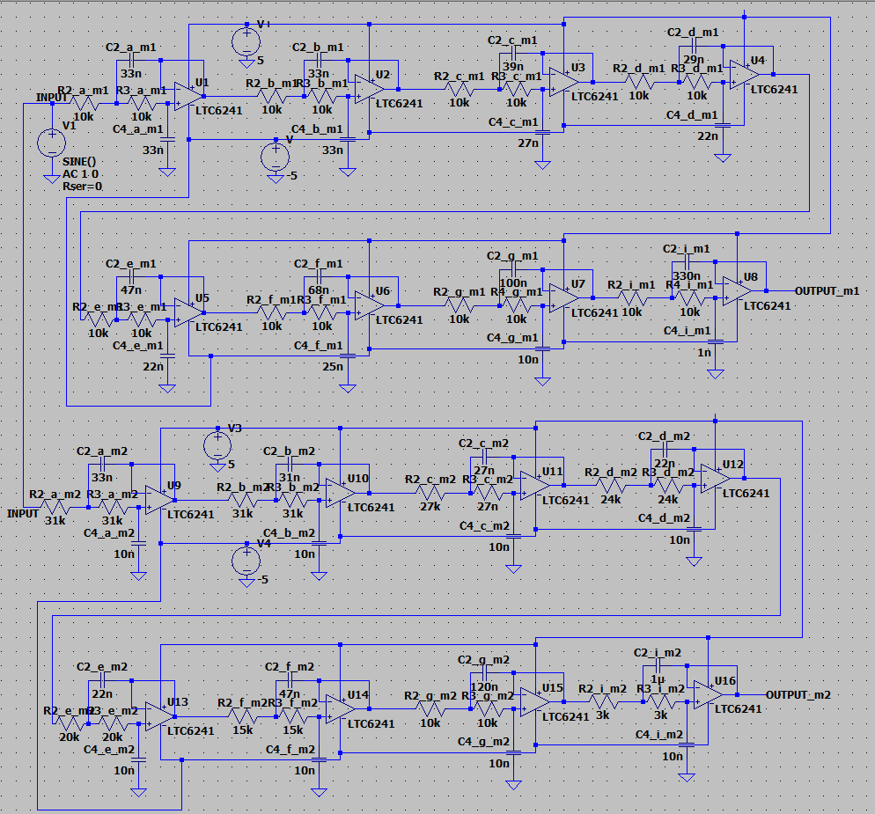

## Standard Capacitor and Resistor values (McClure, n.d.)

